North Shore Ukulele Circle
  - 2026 Songbook – 84 Rocking Songs!
By Title
(Green entries are easier songs)

Accidentally in Love Counting Crows 5
All My Lovin’ Beatles 6
Angel From Montgomery John Prine 7
As It Was Harry Styles 8
Baby I Love Your Way Peter Frampton 9
Badfish Sublime 10
Basket Case Greenday 11
Blue Shadows Randy Newman 12
Both Sides Now Joni Mitchell 13
Brown Eyed Girl Van Morrison 14
Budapest George Ezra 15
Bye Bye, Love Everly Brothers 16
California Dreamin’ Mamas and the Papas 17
California Girls Beach Boys 18
Crazy Willie Nelson 19
Crocodile Rock Elton John 20
Days Like This Van Morrison 21
Down Under Men At Work 22
Dream Lover Bobby Darin 23
Dreams Fleetwood Mac 24
End Of The Line Traveling Wilburys 25
Everybody Wants to Rule the World Tears for Fears 26
Exes and Oh’s Elle King 27
Feel It Still Portugal. The Man 28
Fire and Rain James Taylor 29
Flowers Miley Cyrus 30
Fly Me To the Moon Frank Sinatra 31
Folsom Prison Blues Johnny Cash 32
Friend Of the Devil Grateful Dead 33
Friends In Low Places Garth Brooks 34
The Gambler Kenny Rogers 35
Goodbye Earl Chicks (Dixie Chicks) 36
Handle With Care Traveling Wilburys 37
Happy Together (Lead Vocals) Turtles 38
Happy Together (Backup Vocals) Turtles 39
Harvest Moon Neil Young 40
Hey Soul Sister Train 41
Hold Me Now Thompson Twins 42
Home For A Rest Spirit of the West 43
Hotel California Eagles 44
I’m A Believer Monkees 45
I’m Yours Jason Mraz 46
In the Jailhouse Now Soggy Bottom Boys 47
Invisible Touch Genesis 48
It’s Still Rock & Roll To Me Billy Joel 49
Killing Me Softly Roberta Flack 50
Kokomo Beach Boys 51
Maggie May Rod Stewart 52
Mamma Mia ABBA 53
Man Of Constant Sorrow Soggy Bottom Boys 54
Margaritaville Jimmy Buffet 55
Marry You Bruno Mars 56
No Diggity Blackstreet 57
Nonsense Sabrina Carpenter 58
Octopus’s Garden Beatles 59
The One That Got Away Katy Perry 60
A Pirate Looks at 40 Jimmy Buffet 61
Put Your Records On Corrine Bailey Rae 62
Radioactive Imagine Dragons 63
Ripple Grateful Dead 64
The Rock Show Blink 182 65
Royals Walk Off The Earth 66
Runaround Blues Traveler 67
Sad Songs Say So Much Elton John 68
Santeria Sublime 69
Satisfaction Rolling Stones 70
Sittin’ On the Dock Of the Bay Otis Redding 71
Sloop John B Beach Boys 72
Something Stupid Nancy Sinatra 73
Somewhere Over the Rainbow Israel Kamakawiwo’ole 74
Summer Breeze Seals & Croft 75
Summer Of ’69 Bryan Adams 76
Summer Wind Wayne Newton 77
Take It Easy Eagles 78
Take Me Home, Country Roads John Denver 79
Take On Me A-ha 80
Teenage Dirtbag Wheatus 81
Tiny Bubbles Don Ho 82
Under the Milky Way Tonight Church 83
Vampire Olivia Rodrigo 84
Wagon Wheel Old Crow Medicine Show 85
Waterloo ABBA 86
What’s Up? 4 Non Blondes 87
With Or Without You U2 88
Wonderful World Sam Cooke 89

By Artist

–– 4 ––
4 Non Blondes, What's Up? 87
–– A ––
ABBA, Mamma Mia 53
ABBA, Waterloo 86
A-Ha, Take On Me 80
–– B ––
Beach Boys, California Girls 18
Beach Boys, Kokomo 51
Beach Boys, Sloop John B 72
Beatles, All My Loving 6
Beatles, Octopus's Garden 59
Billy Joel, It’s Still Rock ‘N’ Roll To Me 49
Blackstreet, No Diggity 57
Blink 182, The Rock Show 65
Blues Traveler, Run Around 67
Bobby Darin, Dream Lover 23
Bruno Mars, Marry You 56
Bryan Adams, Summer of '69 76
–– C ––
Chicks (Dixie Chicks), Goodbye Earl 36
Church, Under the Milky Way Tonight 83
Corinne Bailey Rae, Put Your Records On 62
Counting Crows, Accidentally In Love 5
–– D ––
Dixie Chicks (Chicks), Goodbye Earl 36
Don Ho, Tiny Bubbles 82
–– E ––
Eagles, Hotel California 44
Eagles, Take It Easy 78
Elle King, Ex's and Oh's 27
Elton John, Crocodile Rock 20
Elton John, Sad Songs Say So Much 68
Everly Brothers, Bye Bye Love 16
–– F ––
Fleetwood Mac, Dreams 24
Frank Sinatra, Fly Me To The Moon 31
–– G ––
Garth Brooks, Friends In Low Places 34
Genesis, Invisible Touch 48
George Ezra, Budapest 15
Grateful Dead, Friend of the Devil 33
Grateful Dead, Ripple 64
Greenday, Basket Case 11
–– H ––
Harry Styles, As It Was 8
–– I ––
Imagine Dragons, Radioactive 63
Israel Kamakawiwo’ole, Somewhere Over the Rainbow 74
–– J ––
James Taylor, Fire and Rain 29
Jason Mraz, I'm Yours 46
Jimmy Buffet, A Pirate Looks at 40 61
Jimmy Buffet, Margaritaville 55
John Denver, Take Me Home, Country Roads 79
John Prine, Angel From Montgomery 7
Johnny Cash, Folsom Prison Blues 32
Joni Mitchell, Both Sides Now 13
–– K ––
Katy Perry, The One That Got Away 60
Kenny Rogers, The Gambler 35
–– L ––
Lorde, Royals 66
–– M ––
Mamas and the Papas, California Dreamin' 17
Men At Work, Down Under 22
Miley Cyrus, Flowers 30
Monkees, I'm A Believer 45
–– N ––
Nancy Sinatra, Something Stupid 73
Neil Young, Harvest Moon 40
–– O ––
Old Crow Medicine Show, Wagon Wheel 85
Olivia Rodrigo, Vampire 84
Otis Redding, Sittin' On the Dock Of the Bay 71
–– P ––
Peter Frampton, Baby I Love Your Way 9
Portugal. The Man, Feel It Still 28
–– R ––
Randy Newman, Blue Shadows 12
Roberta Flack, Killing Me Softly 50
Rod Stewart, Maggie May 52
Rolling Stones, Satisfaction 70
–– S ––
Sabrina Carpenter, Nonsense 58
Sam Cooke, Wonderful World 89
Seals and Croft, Summer Breeze 75
Soggy Bottom Boys, In the Jailhouse Now 47
Soggy Bottom Boys, Man Of Constant Sorrow 54
Spirit of the West, Home for A Rest 43
Sublime, Badfish 10
Sublime, Santeria 69
–– T ––
Tears for Fears, Everybody Wants To Rule the World 26
Thompson Twins, Hold Me Now 42
Train, Hey Soul Sister 41
Traveling Wilburys, End of the Line 25
Traveling Wilburys, Handle With Care 37
Turtles, Happy Together 38
–– U ––
U2, With Or Without You 88
–– V ––
Van Morrison, Brown Eyed Girl 14
Van Morrison, Days Like This 21
–– W ––
Walk Off The Earth, Royals 66
Wayne Newton, Summer Wind 77
Wheatus, Teenage Dirtbag 81
Willie Nelson, Crazy 19

Accidentally in Love Counting Crows
[G] [C] [G] [A] [G] [C] [Em] [A↓] [A↓] [A↓] 2 3 4  [G] So she said what’s the [C]problem baby  [G] What’s the problem I don't [C]know, well maybe I’m in [Em]love (love)…  think about it [A]every time I think about it [C]Can’t stop thinking ‘bout it  [G] how much longer will it [C]Take to cure this…  [G] just to cure it cos I [C]can’t ignore it if it’s [Em]love (love)  Makes me wanna [A]turn around and face me but I  [C]don't know nothing bout [C]love… oh-oh  [G]Come on [Am]come on… [C]turn a little [D]faster  [G]Come on [Am]come on… [C]the world will follow [D]after  [G]Come on [Am]come on cos [C]everybody's [D]after  [Em]love [A] [C] [pause]  [G] So I said I'm a [C]snowball running  [G] Running down into the [C]spring that’s coming All this [Em]love…  melting under [A]blue skies belting out [C]Sunlight shimmering  [G]love… well baby [C]I surrender to the  [G]strawberry ice cream [C]Never ever end of all this [Em]love  Well I [A]didn’t mean to do it but there’s no escaping your  [C]love… oh-oh  [Em] These lines of [C]lightning mean we’re  [G]Never alone [Am]never alone [no chord]no no  [G]Come on [Am]come on… [C]move a little [D]closer  [G]Come on [Am]come on… [C]I want to hear you [D]whisper  [G]Come on [Am]come on… [C]settle down in[D]side my  [Em]Love [D]  [G]Come on [Am]come on… [C]jump a little [D]higher  [G]Come on [Am]come on… [C]if you feel a little [D]lighter  [G]Come on [Am]come on we were [C]once upon a [D]time in  [Em]Love [A] [C] [pause]  ( We’re accidentally [G]in love [C] We’re accidentally [Em]in love [D] ) x4  [G] I'm in love, I'm in [C]love, I'm in love,  I'm in [Em]love, I'm in love, I'm in [D]love... accidentally  [G] I'm in love, I'm in [C]love, I'm in love,  I'm in [Em]love, I'm in love, I'm in [D]love... accidentally  [G]Come on [Am]come on… [C]spin a little [D]tighter  [G]Come on [Am]come on… and the [C]world's a little [D]brighter  [G]Come on [Am]come on… just [C]get yourself in[D]side her  [Em]Love... [D] I'm in love [G↓] | 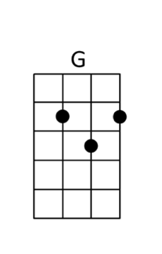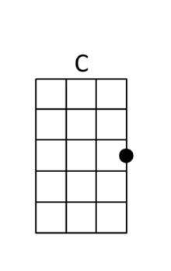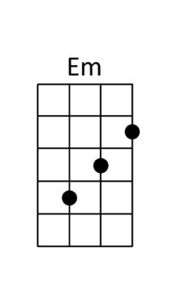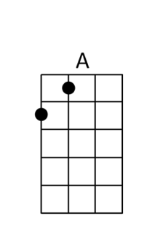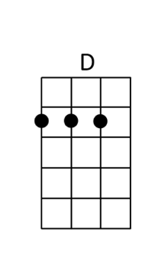

All My Lovin’ Beatles
Close your [Dm]eyes and I’ll [G7]kiss you,  to[C]morrow i’ll [Am]miss you,  re[F]member I’ll [Dm]always be [C]true. [G7]  And then [Dm]while I’m a[G7]way I’ll write  [C]home every[Am]day  and I’ll [F]send all my [G7]loving to [C]you.  I’ll pre[Dm]tend that I’m [G7]kissing,  the [C]lips I am [Am]missing  and [F]hope that my [Dm]dreams will come [C]true. [G7]  And then [Dm]while I’m a[G7]way I’ll write  [C]home every[Am]day  and I’ll [F]send all my [G7]loving to [C]you.  All my [Am]loving [G#+]I’ll will send to [C]you.  All my [Am]loving, [G#+]darling I’ll be [C]true.  Close your [Dm]eyes and I’ll [G7]kiss you,  to[C]morrow I’ll [Am]miss you,  re[F]member I’ll [Dm]always be [C]true. [G7]  And then [Dm]while I’m a[G7]way I’ll write  [C]home every[Am]day  and I’ll [F]send all my [G7]loving to [C]you.  All my [Am]loving [G#+]I’ll will send to [C]you.  All my [Am]loving, [G#+]darling I’ll be [C]true.  All my [Am]loving  All my [C]loving, oooooh  All my [Am]loving, I will send to [C]you | 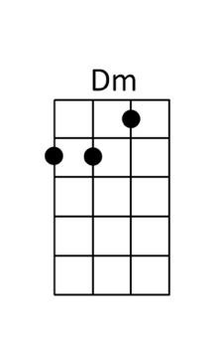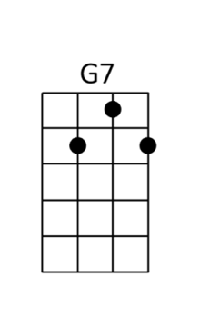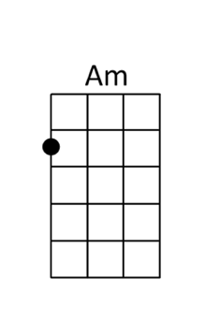
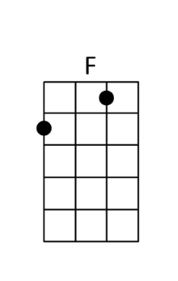 | 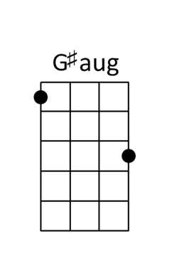

Angel From Montgomery John Prine
[D] [G]  [D] [G]  [D] I am an old [G] woman [D] named after my [G] mother.  [D] My old man is a-[G]nother [A] child that's grown [D] old.  If dreams were [G] thunder [D] and lightning was de-[G]sire  [D] this old house would've [G] burnt down a [A] long time a-[D]go.  [D] Make me an [C] angel that [G] flies from Mont-[D]gomery.  Make me a [C] poster of [G] an old rodeo[D].  Just give me [C] one thing that [G] I can hold [D] on to.  To believe in this [G] living is just a [A] hard way to [D] go. [G]  [D] [G]  [D] When I was a young [G] pup [D] you had [G] a cowboy,  [D] wasn't much to [G] look at, [A] just a free rambl-in' [D] man.  But that was a [G] long time, and [D] no matter how [G] I try,  [D] the years can't go [G] back like a [A] broken down [D] dam.  [D] Make me an [C] angel that [G] flies from Mont-[D]gomery.  Make me a [C] poster of [G] an old rodeo[D].  Just give me [C] one thing that [G] I can hold [D] on to.  To believe in this [G] living is just a [A] hard way to [D] go.  [G] [D] [G]  [D] There's flies in the [G] kitchen, I can [D] hear all their [G]buzzin'  [D] but I ain't done [G] nothin' since I [A] woke up today[D].  But how the hell [G] can a person go to [D] work in the [G] morning [D] come home in the [G] evenin' and have nothin' [A] to say? [D]  [D] Make me an [C] angel that [G] flies from Mont-[D]gomery.  Make me a [C] poster of [G] an old rodeo[D].  Just give me [C] one thing that [G] I can hold [D] on to.  To believe in this [G] living is just a [A] hard way to [D] go.  To believe in this [G↓] living is just a [A↓] hard way to [D↓] go. | 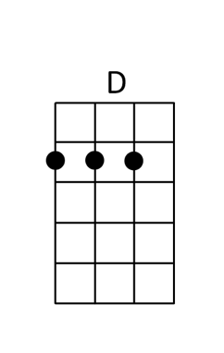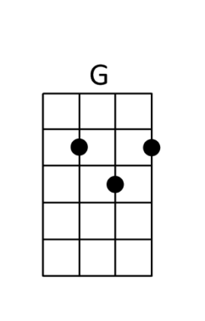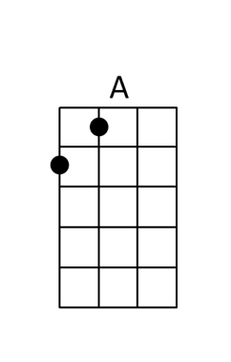

As It Was Harry Styles
Come on, Harry, we wanna say goodnight to you  [A#] [Gm] [C] [F]  [A#] Holdin' me back  Gravity's [Gm] holdin' me back  I want you to [C] hold out the palm of your hand  Why don't we [F] leave it at that?  [A#] Nothin' to say  When everything [Gm] gets in the way  Seems you can [C] not be replaced  And I'm the [F] one who will stay, ohohoh  PRE-CHORUS  [A#] In this world, [Gm] it's just us [C]  You know [F] it's not the same as it [A#] was  In this world, [Gm] it's just us [C]  You know [F] it's not the same as it [A#] was  CHORUS  As it [Gm] was, as it [C] was  You know [F] it's not the same  [A#] Answer the phone  Harry, you're [Gm] no good alone  Why are you [C] sitting at home on the floor?  What kind of [F] pills are you on?  [A#] Ringin' the bell  And nobody's [Gm] coming to help  Your daddy [C] lives by himself  He just wants [F] to know that you're well, ohohoh  REPEAT PRE-CHORUS  REPEAT CHORUS  BRIDGE  [A#] Go home, get ahead, lightspeed internet  [Gm] I don't wanna talk about the way that it was  [C] Leave America, two kids follow her  [F] I don't wanna talk about who's doin' it first  [A#] Hey  [Gm] [C] As it [F] was  You know [A#] it's not the same as it [Gm] was  As it [C] was, as it [F] was [A#↓] | 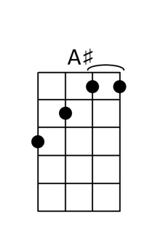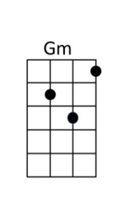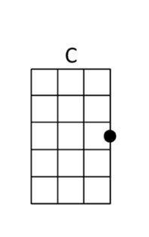

Baby I Love Your Way Peter Frampton
[C]Shadows grow so [Em]long before my [Am]eyes
And they're [F]moving ac[Fm]ross the page
[C]Suddenly the [Em]day turns into [Am]night
Far [F]away from the [Fm]city
[Em]Don't hesi[Am]tate
'Cause your [Dm]love won't [G7]wait

[C] Ooh [G]baby I love your [Dm]way, every[F]day
[C] Wanna [G]tell you I love your [Dm]way, every[F]day
[C] Wanna [G]be with you night and [Dm]day [F]

[C]Moon appears to [Em]shine and light the [Am]sky
With the [F]help of some [Fm]firefly
[C]Wonder how they [Em]have the power to [Am]shine, shine, shine
I can [F]see them [Fm]under the pine
[Em]Don't hesi[Am]tate
'Cause your [Dm]love won't [G7]wait

[C] Ooh [G]baby I love your [Dm]way, every[F]day
[C] Wanna [G]tell you I love your [Dm]way, every[F]day
[C] Wanna [G]be with you night and [Dm]day [F]

[C]I can see the [Em]sunset in your [Am]eyes
Brown and [F]gray, and [Fm]blue besides
[C]Clouds are stalking [Em]islands in the [Am]sun
I wish I could [F]buy one Out of [Fm]season

[Em]Don't hesi[Am]tate
'Cause your [Dm]love won't [G7]wait

[C] Ooh [G]baby I love your [Dm]way, every[F]day
[C] Wanna [G]tell you I love your [Dm]way, every[F]day
[C] Wanna [G]be with you night and [Dm]day [F]

[C] Ooh [G]baby I love your [Dm]way, every[F]day
[C] Wanna [G]tell you I love your [Dm]way, every[F]day
[C] Wanna [G]be with you night and [Dm]day [F] [C↓]
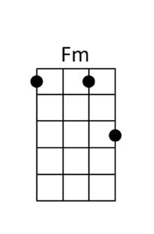

Badfish Sublime
[A][Bm][G][A]  [A]When you grab a hold of [Bm]me  [G]Tell me that I'll never be set [A]free  [A]But I'm a [Bm]parasite  Creep and [G]crawl I step into the [A]night  [A]Two pints of [Bm]booze  Tell me[G] are you a badfish [A]too?  [D]Ain't got no money to [A]spend  [D]I hope this night will never [A]end  [D]Lord knows I'm [A]weak  Won't some[D]body get me off of this [E]reef  [A]Baby you're a big blue [Bm]whale  [G]Grab the reef when all duck diving [A]fails  [A]I swim, but wish I'd never [Bm]learned  [G]The water's too polluted with [A]germs  [A]I dive deep when it's ten feet over[Bm]head  [G]Grab the reef underneath my [A]bed  CHORUS  [D]Ain't got no quarrels with [A]God  [D]Ain't got no time to grow [A]old  [D]Lord knows I'm [A]weak  Won't some[D]body get me off of this [E]reef  [A][Bm][G][A]  A Bm  A|----------------------------------------|  E|-7h9--7/9--7b9b7---7--------------------|  C|----------------------------------------|  G|----------------------------------------|  G A  A|----------------------------------------|  E|-----5p4--------------------------------|  C|-4h6-------4h6p4------------------------|  G|----------------6-4/6-------------------|  Bm G  A|----------------------------------------|  E|-------------5p4------------------------|  C|---4h6-6---4----4/6-6-------------------|  G|-6--------------------------------------|  A  A|-12-------------------------------------|  E|---12-----------------------------------|  C|-----13-11-13\11~~~---------------------|  G|----------------------------------------|  REPEAT CHORUS | 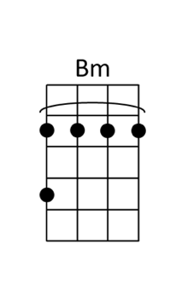

Basket Case Greenday
[D]Do you have the [A]time  To [Bm]listen to me [F#m]whine  A[G]bout nothing and [D]everything all at [A]once  [D]I am one of [A]those  Me[Bm]lodramatic [F#m]fools  Neu[G]rotic to the [D]bone, no doubt about it[A] [A]  [G] Sometimes I [A]give myself the [D]creeps  [G] Sometimes my [A]mind plays tricks [D]on me  It [G]all keeps adding [A]up  I [D]think I’m [C]cracking [Bm]up  Am [G]I just para[A]noid?  Am I just stoned? ( [D↓↓] [A↓↓] [Bm↓↓] [A↓↓] ) x2  I [D]went to a [A]shrink  To [Bm]analyze my [F#m]dreams  She [G]says it’s lack of [D]sex  That’s bringing me [A]down  I [D]went to a [A]whore  He [Bm]said my life’s a [F#m]bore  So [G]quit my whining [D]cause  It’s bringin her [A]down [A]  [G] Sometimes I [A]give myself the [D]creeps  [G] Sometimes my [A]mind plays tricks [D]on me  It [G]all keeps adding [A]up  I [D]think I’m [C]cracking [Bm]up  Am [G]I just para[A]noid?  Am I just stoned? ( [D↓↓] [A↓↓] [Bm↓↓] [A↓↓] ) x4  [G]Grasping to con[A]trol so I better hold[D] on[A]  [Bm] [F#m] [G] [D] [A] [A]  [Bm] [F#m] [G] [D] [A] [A]  [G] Sometimes I [A]give myself the [D]creeps  [G] Sometimes my [A]mind plays tricks [D]on me  It [G]all keeps adding [A]up  I [D]think I’m [C]cracking [Bm]up  Am [G]I just para[A]noid?  Am I just stoned? ( [D↓↓] [A↓↓] [Bm↓↓] [A↓↓] ) x4  [G] [D] [A] | 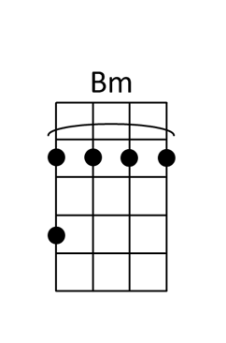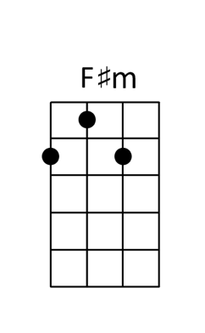

Blue Shadows Randy Newman
D B7 Em7 A+ D B7 Em7 A+  D A7 D D7  Arizona moon keep shin-ing  G Gm D D7  From the desert sky above  G Gm D B7  You know pretty soon, that big yellow moon  Em7 A7  Will light the way back to the one you love  D B7 Em7 A7 D B7 Em7 A7  Blue Sha-dows on the trail  D D DM7 DM7 D7 D7 B7 B7  Little cowboy, close your eyes and dream  Em7 A7 D Bm7  All of the doggies are in the corral  Em7 A7 D D7  All of your work is done  G Gm DM7 B7  Just close your eyes and dream little pal  E7↓ A+↓  Dream of, Someone  D B7 Em7 A7 D B7 Em7 A7  Blue Sha-dows on the trail  D D DM7 DM7 D7 D7 B7 B7  Soft wind blowing through the trees above  Em7 A7 D B7  All the other little cowboys  Em7 A7 F#7↓ B7↓  Back in the bunkhouse now, so  E7↓ A+↓  close your… eyes and..  ( D B7 Em7 A+ )  ( Dream.. ) x3  D | 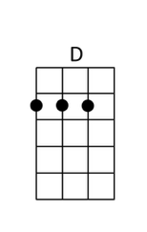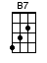  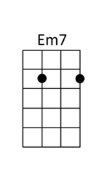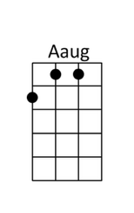  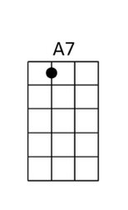  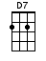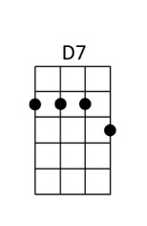  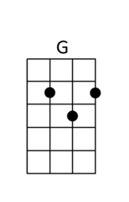  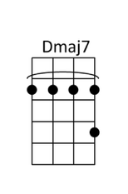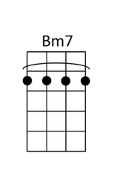  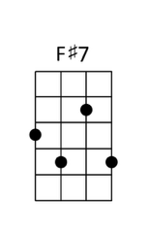

Both Sides Now Joni Mitchell
[G][C][G][C] x2  [G]Rows and [Am]flows of [C]angel [G]hair  and ice cream [Bm]castles [C]in the [G]air  And feather [C]canyons every[Am]where,  I've [C]looked at clouds that [D]way.  But [G]now they [Am]only [C]block the [G]sun,  they rain and [Bm]snow on [C]every[G]one.  So many [C]things I [Am]would have done  but [C]clouds got in my [D]way.  I've [G]looked at [Am]clouds from [C]both sides [G]now,  From [C]up and [G]down, and [C]still some[G]how  It's [Bm]clouds il[C]lusions [G]I recall.  I [C]really don't know [D]clo-[D7]uds [D]at [G]all. [G][C][G][C]  [G]Moons and [Am]Junes and [C]Ferris [G]wheels,  the dizzy [Bm]dancing [C]way you [G]feel  When every [C]fairy [Am]tale comes real;  I've [C]looked at love that [D]way.  But [G]now it's [Am]just a[C]nother [G]show,  you leave 'em [Bm]laughing [C]when you [G]go  And if you [C]care, don't [Am]let them know,  don't [C]give yourself a[D]way.  I've [G]looked at [Am]love from [C]both sides [G]now,  From [C]give and [G]take, and [C]still some[G]how  It's [Bm]love's il[C]lusions [G]I recall.  I [C]really don't know [D]lo-[D7]ve [D] at [G]all. [G][C][G][C]  [G]Tears and [Am]fears and [C]feeling [G]proud  to say "I [Bm]love you" [C]right out [G]loud,  Dreams and [C]schemes and [Am]circus crowds,  I've [C]looked at life that [D]way.  But [G]now old [Am]friends are [C]acting [G]strange,  they shake their [Bm]heads, they [C]say I've [G]changed.  But something's [C]lost but [Am]something's gained  in [C]living every [D]day.  I've [G]looked at [Am]life from [C]both sides [G]now,  From [C]win and [G]lose, and [C]still some[G]how  It's [Bm]life's il[C]lusions [G]I recall.  I [C]really don't know [D]li-[D7]fe [D] at [G]all[G]. [C][G][C][G↓] | 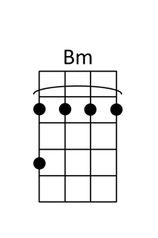

Brown Eyed Girl Van Morrison
[Intro] x2
[G] [C] [G] [D]
A|2-3-5-3-2-|7--8-10--8-7-|2-3-5-3-2-|--------|
E|3-5-7-5-3-|8-10-12-10-8-|3-5-7-5-3-|2-2-3-5-|
C|----------|-------------|----------|2-------|
G|----------|-------------|----------|--------|

[G] Hey where did we [C] go, [G] days when the [D] rains came
[G] Down in the [C] hollow, [G] playin’ a [D] new game
[G] Laughing, and a [C] running, hey, hey, [G] skipping and a [D] jumping
[G] In the misty [C] morning fog with, [G] our hearts a [D] thumpin’ and
[C] You, [D] my brown eyed [G] girl [Em]
[C] You my, [D] brown eyed [G] girl [D7]

[G] Whatever [C] happened [G] to Tuesday and [D] so slow
[G] Going down the [C] old mine with a [G] transistor [D] radio
[G] Standing in the [C] sunlight laughing, [G] hidin’ ‘hind a [D] rainbow’s wall
[G] Slipping and a [C] sliding, hey, hey, [G] All along the [D] waterfall with
[C] You, [D] my brown eyed [G] girl [Em],
[C] You [D] my brown-eyed [G] girl
[D7] Do you remember when, we used to [G] sing

Sha la la la [C] la la la la [G] la la la la te [D] da,
[G] Sha la la la [C] la la la la [G] la la la la te [D] da,
la te [G] da

[G] So hard to [C] find my way, [G] Now that I’m [D] on my own
[G] I saw you just the [C] other day, [G] my, how you have [D] grown
[G] Cast my memory [C] back there Lord.
[G] Sometimes I’m overcome [D] thinkin’ ‘bout it
[G] Makin’ love in the [C] green grass [G] behind the [D] stadium with
[C] You, [D] my brown eyed [G] girl. [Em]
[C] You [D] my brown eyed [G] girl.
[D7] Do you remember when, we used to [G] sing

Sha la la la [C] la la la la [G] la la la la te [D] da
[G] Sha la la la [C] la la la la [G] la la la la te [D] da
[G] Sha la la la [C] la la la la [G] la la la la te [D] da
[G] Sha la la la [C] la la la la [G] la la la la te [D] da,
la te [G↓] da

Budapest George Ezra
G  My house in Budapest. My hidden treasure chest.  Golden grand piano. My beautiful Castillo  C … C5 C … C5 G…Gs4 G…Gs4  You–hoo, you; I’d leave it all  C … C5 C … C5 G…Gs4 G…Gs4  Oh for you-hoo, you; I’d leave it all  D…As4 C G…Gs2 G…Gs4  Give me one good reason Why I should never make a change  D…As4 C G…Gs2 G…Gs4  And baby if you hold me Then all of this will go away  G  My many artifacts, the list goes on.  If you just say the words I’ll, I’ll up and run  C … C5 C … C5 G…Gs4 G…Gs4  Oh to you–hoo, you; I’d leave it all  C … C5 C … C5 G…Gs4 G…Gs4  But for you-hoo, you; I’d leave it all  D…As4 C G…Gs2 G…Gs4  Give me one good reason Why I should never make a change  D…As4 C G…Gs2 G…Gs4  And baby if you hold me Then all of this will go away  G  My friends and family, they don’t understand.  They fear they’d lose so much if you took my hand  C … C5 C … C5 G…Gs4 G…Gs4  But for you-hoo, you; I’d lose it all  C … C5 C … C5 G…Gs4 G…Gs4  Oh for you-hoo, you; I’d lose it all  D…As4 C G…Gs2 G…Gs4  Give me one good reason Why I should never make a change  D…As4 C G…Gs2 G…Gs4  And baby if you hold me Then all of this will go away  G  My house in Budapest. My hidden treasure chest.  Golden grand piano. My beautiful Castillo  C … C5 C … C5 G…Gs4 G…Gs4  You–hoo, you; I’d leave it all  C … C5 C … C5 G…Gs4 G…Gs4 G↓  Oh for you-hoo, you; I’d leave it all | 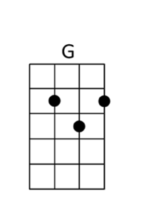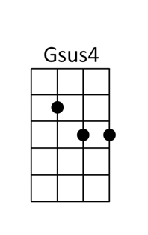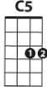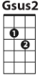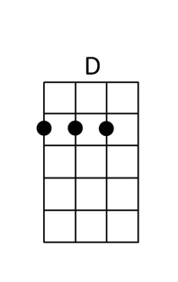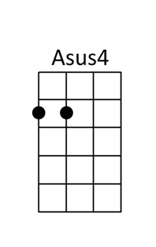

Bye Bye, Love Everly Brothers
( [F] [Ab] [Bb] [F] ) x2  [Bb] Bye, bye, [F] love, [Bb] bye bye, [F] happiness  [Bb] Hello, [F] loneliness, I think I’m [C7] gonna [F] cry  [Bb] Bye, bye, [F] love, [Bb] bye bye, [F] sweet caress  [Bb] Hello, [F] emptiness, I feel like [C7] I could [F] die  Bye bye, my [C7] love, good[F]bye  There goes my [C7] baby with someone [F] new  She sure looks [C7] happy, I sure am [F] blue [C7]  She was my [Bb] baby, till he stepped [C7] in  Goodbye to romance that might have [F] been [C7]  [Bb] Bye, bye, [F] love, [Bb] bye bye, [F] happiness  [Bb] Hello, [F] loneliness, I think I’m [C7] gonna [F] cry  [Bb] Bye, bye, [F] love, [Bb] bye bye, [F] sweet caress  [Bb] Hello, [F] emptiness, I feel like [C7] I could [F] die  Bye bye, my [C7] love, good[F]bye  [F] I’m through with [C7] romance, I’m through with [F] love  I’m through with [C7] counting the stars a[F]bove [C7]  And here’s the [Bb] reason that I’m so [C7] free  My loving baby is through with [F] me [C7]  [Bb] Bye, bye, [F] love, [Bb] bye bye, [F] happiness  [Bb] Hello, [F] loneliness, I think I’m [C7] gonna [F] cry  [Bb] Bye, bye, [F] love, [Bb] bye bye, [F] sweet caress  [Bb] Hello, [F] emptiness, I feel like [C7] I could [F] die  Bye bye, my [C7] love, good[F]bye  ( [F] [Ab] [Bb] [F] ) x2 | 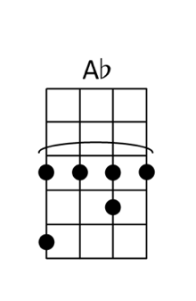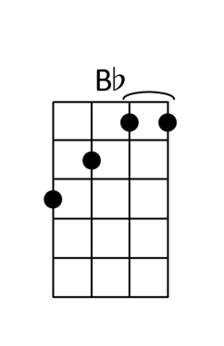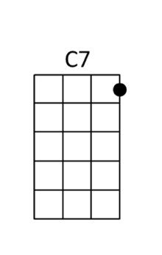

California Dreamin’ Mamas and the Papas
A|---0-2---5--3--2-|---0---------5---|-3---5-3-2--0----|-2--|  E|-0-----0---------|-0---0-1-0-------|---------------3-|-0--|  C|-----------------|-----------------|-----------------|-2--|  G|-----------------|-----------------|-----------------|-2--|  All the leaves are [Dm]brown [C] [Bb]  (all the leaves are brown)  And the [C]sky is [Asus4]gray [A7]  (and the sky is gray)  I've been for a [F]walk [A7] [Dm]  (I've been for a walk)  On a [Bb]winter's [Asus4]day [A7]  (on a winter's day)  I'd be safe and [Dm]warm [C] [Bb]  (I'd be safe and warm)  If I [C]was in L.A.[Asus4] [A7]  (if I was in L. A.)  California [Dm]dreamin' [C] [Bb]  (Cali----fornia dreamin')  On [C]such a winter's [Asus4]day [A7]  Stopped in to a [Dm]church [C] [Bb]  I passed a[C]long the [Asus4]way [A7]  Well I [Bb]got down on my [F]knees [A7] [Dm]  (got down on my knees)  And I pre[Bb]tend to [Asus4]pray [Asus4] [A7] You know  (I pretend to pray)  the preacher likes the [Dm]cold [F] [Bb]  (preacher likes the cold)  He knows I'm [C]gonna [Asus4]stay [A7][A7]  (knows I'm gonna stay)  California drea[Dm]min'[F][Bb]  (California dreamin')  On [C]such a winter's [Asus4]day [A7]  [Dm]Doo 2 3 4 | 1 _{do} ^{do} _{do} ^{do} _{do} ^{do} | Doo 2 3 4 | ₁ ^{do} _{do} ^{do} _{do} ^{do} _{do} ^{do} |  [F]Doo 2 [A7]Doo 4 | [Dm]Doo 2 [Bb]Doo 4 | [Asus4]Doo 2 3 4 |  [A7] 2 _{da} ^{da} Daa | [Dm]Daa daa [C]daa 4 | [Bb]daa daa [C]daa 4 |  [Asus4]daa daa _{da} ^{da} _{da} ^{da} | [A7]daa 2 _{da} ^{da} daa |  [Dm]daa daa [C]daa daa | [Bb]daa daa [C]daa daa | [Asus4]daa 2 3 4 |  [A7]daa 2 _{All} ^{the} _{leaves} ^{are} | [Dm]brown [C] [Bb]  (all the leaves are brown)  And the [C]sky is [Asus4]gray [A7]  (and the sky is gray)  I've been for a [F]walk [A7] [Dm]  (I've been for a walk)  On a [Bb]winter's [Asus4]day [A7]  (on a winter's day)  If I didn't [Dm]tell her [C] [Bb] I could [C]leave  (if I didn't tell her)  to[Asus4]day  (I could leave to[A7]day)  California [Dm]dreamin' [C] [Bb] On such  (Cali----fornia dreamin')  a [C]winter’s [Dm] [C] [Bb] On such  (Cali----fornia dreamin')  a [C]winter’s [Dm] [C] [Bb] On such  (Cali----fornia dreamin')  a [C]winter’s [Bbmaj7]day [Bbmaj7] [Dm↓] | 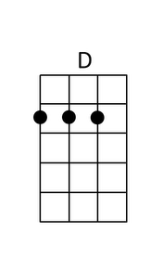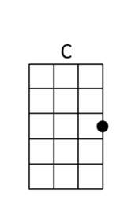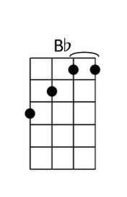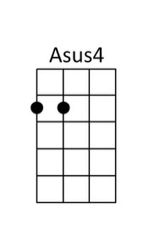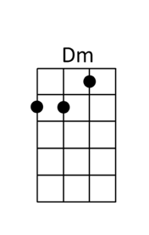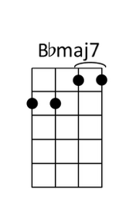

California Girls Beach Boys
Well [A] east coast girls are hip  I really [Em7] dig those styles they wear  And the [D] southern girls with the way they talk  They knock me [E7] out when I'm down there  The [A] midwest farmers' daughters  Really [Em7] make you feel alright  And the [D] northern girls with the way they kiss  They keep their [E7] boyfriends warm at night  I [A]wish they all could  [Bm]be California [G]girls [Am]  (I wish they all could be California)  I [F]wish they all could [Gm7]be California [A]girls [A]  The [A] west coast has the sunshine  And the [Em7] girls all get so tanned  I dig a [D] French bikini on Hawaiian Islands dolls  By a [E7] palm tree in the sand  I’ve [A] been all around this great big world  And I've [Em7] seen all kind of girls  Yeah but [D] I couldn't wait to get back in the states  Back to the [E7] cutest girls in the world  I [A]wish they all could  [Bm]be California [G]girls [Am]  (I wish they all could be California)  I [F]wish they all could [Gm7]be California [A]girls [A]  I [A] wish they all could be California  I [Bm] wish they all could be California  I [A] wish they all could be California  I [Bm] wish they all could be California [A] girls | 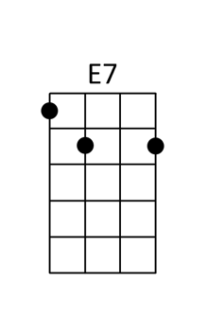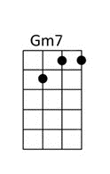

Crazy Willie Nelson
I'm [C]crazy,  [A7]crazy for feeling so [Dm]lonely [Dm7] [Dm6]  I'm [G]crazy,  [G7]crazy for feeling so [C]blue [Gdim] [Dm7] [G7]  [C]I knew  you'd [A7]love me as long as you [Dm]wanted [Dm7] [Dm6]  And then [G]someday  you'd [G7]leave me for somebody [C]new [F] [C] [C7]  [F]Worry,  [F]why do I let myself [C]worry? [C7]  [D]Wond'rin  [D7]what in the world did I [G]do? [Dm7] [G7]  [C]Crazy,  for [A7]thinking that my love could [Dm]hold you [Dm7] [Dm6]  I'm [F] crazy for [Em7] trying and  [Dm7] crazy for [Gdim] crying  And I'm [Dm7] crazy for [G7] loving you [C]  I'm [C]crazy,  [A7]crazy for feeling so [Dm]lonely [Dm7] [Dm6]  I'm [G]crazy,  [G7]crazy for feeling so [C]blue [Gdim] [Dm7] [G7]  [C]I knew  you'd [A7]love me as long as you [Dm]wanted [Dm7] [Dm6]  And then [G]someday  you'd [G7]leave me for somebody [C]new [F] [C] [C7]  [F]Worry,  [F]why do I let myself [C]worry? [C7]  [D]Wond'rin  [D7]what in the world did I [G]do? [Dm7] [G7]  [C]Crazy,  for [A7]thinking that my love could [Dm]hold you [Dm7] [Dm6]  I'm [F] crazy for [Em7] trying and  [Dm7] crazy for [Gdim] crying  And I'm [Dm7] crazy for [G7] loving you [C]  [F] [C] [F] [C] | 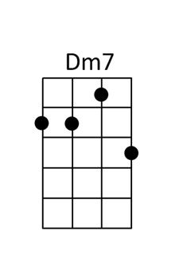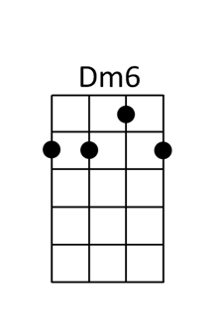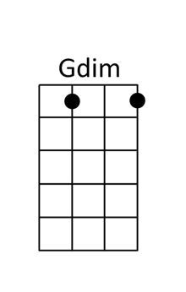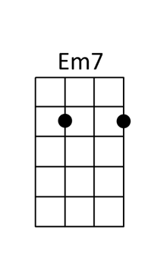

Crocodile Rock Elton John
INTRO: / 1 2 3 4 /  [G↓] / [C↓] / [F#↓] /  [G] / [G] / [Em] / [Em] /  [C] / [C] / [D7] / [D7]  VERSE 1  I re-[G]member when rock was [G]young  Me and [Bm]Susie had so much [Bm]fun  Holdin’ [C]hands and skimmin’ [C]stones  Had an [D7]old gold Chevy and a [D7]place of my own  But the [G]biggest kick I ever [G]got  Was doin' a [Bm]thing called the Crocodile [Bm]Rock  While the [C]other kids were rockin' 'round the [C]clock  We were [D7]hoppin' and boppin' to the [D7]Crocodile Rock, well  CHORUS  [Em]Crocodile Rockin' is [Em]something shockin'  When your [A7]feet just can't keep [A7]still  [D7]I never knew me a [D7]better time and I[G]guess I never [G]will  [E7]Oh, lawdy mamma, those [E7]Friday nights  When [A7]Susie wore her [A7]dresses tight and  [D7]Crocodile Rockin' was [D7]ou-ou-out of [C]si-i-[C]-i-ight  [G]Laaaa [G]la la la la [Em]laaaa [Em]la la la la la  [C]Laaaa [C]la la la la la [D7]laaaa [D7]  VERSE 2  But the [G]years went by, and the [G]rock just died  [Bm]Susie went and left us for some [Bm]foreign guy  [C]Long nights cryin' by the [C]record machine  [D7]Dreamin' of my Chevy and my [D7]old blue jeans  But they'll [G]never kill the thrills we've [G]got  Burnin’ [Bm]up to the Crocodile [Bm]Rock  Learnin’ [C]fast till the weeks went [C]past  We really [D7]thought the Crocodile [D7]Rock would last, well  REPEAT CHORUS  REPEAT VERSE 1  REPEAT CHORUS  [G]Laaaa [G]la la la la [Em]laaaa [Em]la la la la la  [C]Laaaa [C]la la la la la [D7]laaaa [D7]  [G]Laaaa [G]la la la la [Em]laaaa [Em]la la la la la  [C]Laaaa [C]la la la la la [D7]laaaa [G↓] | 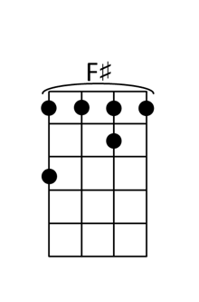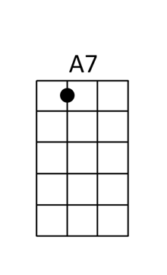

Days Like This Van Morrison
[F][C][F][C][x2]

When it’s [C]not always [Am]raining there’ll be [F]days like [C]this
When there’s [C]no one comp[Am]laining there’ll be [F]days like [C]this
Everything [F]falls into pl[G]ace like the [C]flick of [G]a switch[Am]
Well my [Dm7]mama told [G]me there’ll be [F]days like [C]this[F][C]

When you [C]don’t need to [Am]worry there’ll be [F]days like [C]this
When no [C]one’s in a [Am]hurry there’ll be [F]days like [C]this
When you [F]don’t get bet[G]rayed by that o[C]ld J[G]udas k[Am]iss
Oh, my [Dm7]mama told m[G]e there’ll be [F]days like [C]this[F][C]

When you [C]don’t need an [Am]answer there’ll be [F]days like [C]this
When you [C]don’t meet a [Am]chancer there’ll be [F]days like [C]this
When all the [F]parts of the puzz[G]le start to [C]look like [G]they [Am]fit
Then I [Dm7]must remembe[G]r there’ll be [F]days like [C]this[F][C]

Instrumental
When it’s [C]not always [Am]raining there’ll be [F]days like [C]this
When there’s [C]no one comp[Am]laining there’ll be [F]days like [C]this
Everything [F]falls into pl[G]ace like the [C]flick of [G]a switch[Am]
Well my [Dm7]mama told [G]me there’ll be [F]days like [C]this[F][C]

When every[C]one is up fron[Am]t and they’re [F]not playing [C]tricks
When you [C]don’t have no freeloa[Am]ders out to [F]get their [C]kicks
When it’s [F]nobody’s busine[G]ss the way that [C]you wa[G]nna l[Am]ive
I just [Dm7]have to reme[G]mber there’ll be [F]days like [C]this[F][C]

When no one [C]steps on my [Am]dreams there’ll be [F]days like [C]this
When people under[C]stand what I [Am]mean there’ll be [F]days like [C]this
When you [F]ring out the chang[G]es of how [C]every[G]thing [Am]is
Well my [Dm7]mama told m[G]e there’ll be [F]days like [C]this[F][C]

Na na [C]na, na na [Am]na na[F][C]
Na na [C]na, na na [Am]na na[F][C]
[F] [G] [C] [G] [Am]

Oh, my [Dm7]mama told [G]me
There’ll be [F]days like [C]this
Oh, my [Dm7]mama told me[G]
There’ll be [F]days like [C]this
Oh, my [Dm7]mama told me[G]
There’ll be [F]days like [C]this
Oh, my [Dm7]mama told me[G]
There’ll be [F]days like [C]this

Down Under Men At Work
[Bm] Travelling in a [A] fried-out Kombi [Bm] [G] [A]
[Bm] On a hippie[A] trail head full of [Bm] zombie [G] [A]
[Bm] I met a strange[A] lady she [Bm] made me [G]nervous [A]
[Bm] She took me [A] in and gave me [Bm] breakfast
[G] And she [A] said

[D] Do you come from a [A] land down under? [Bm] [G] [A]
[D] Where women [A] glow and men plunder? [Bm] [G] [A]
[D] Can't you hear can't you [A] hear the thunder? [Bm] [G] [A]
You [D] better run you [A] better take cover [Bm] [G] [A]

[Bm] Buying bread from a man in [A] Brussels [Bm] [G] [A]
He was [Bm] six foot four [A] and full of [Bm] muscles [G] [A]
[Bm] I said Do you [A] speak my language? [Bm] [G] [A]
[Bm] He just smiled and [A] gave me a vegemite [Bm] sandwich
[G] And he [A] said

[D] I come from a [A] land down under [Bm] [G] [A]
[D] Where beer [A] flows and men chunder [Bm] [G] [A]
[D] Can't you hear can't you [A] hear the thunder? [Bm] [G] [A]
You [D] better run you [A] better take cover [Bm] [G] [A]

[Bm] Lying in a [A] den in Bombay [Bm] [G] [A]
[Bm] With a slack [A] jaw, and not much [Bm] to say [G] [A]
[Bm] I said to the [A] man Are you trying to [Bm] tempt me [G] [A]
[Bm] Because I come [A] from the land of [Bm] plenty?"
[G] And he [A] said

[D] Do you come from a [A] land down under? [Bm] [G] [A]
[D] Where women [A] glow and men plunder? [Bm] [G] [A]
[D] Can't you hear can't you [A] hear the thunder? [Bm] [G] [A]
You [D] better run you [A] better take cover [Bm] [G] [A]

[D] Do you come from a [A] land down under? [Bm] [G] [A]
[D] Where women [A] glow and men plunder? [Bm] [G] [A]
[D] Can't you hear can't you [A] hear the thunder? [Bm] [G] [A]
You [D] better run you [A] better take cover [Bm] [Bm↓]

Dream Lover Bobby Darin
[C] Every night I hope and pray  [Am] a dream lover will come my way  [C] A girl to hold in my arms  [Am] and know the magic of her charms  Because I [C] want a [G7] girl to  [C] call my [F] own [Fm]  I want a [C] dream [Am] lover so  [Dm7] I won't have to [G7] dream a-[C]lone  [F] [C] [G7]  [C] Dream lover, where are you  [Am] with a love, oh, so true  [C] And the hand that I can hold [Am]  to feel you near as I grow old  Because I [C] want a [G7] girl to  [C] call my [F] own [Fm]  I want a [C] dream [Am] lover so [Dm7]  I won't have to [G7] dream a-[C]lone  [F] [C] [G7]  [C] Someday, I don't know how  [C] I hope she'll hear my plea  [D7] Some way, I don't know how [G7]  [no chord]  She'll bring her love to me  [C] Dream lover, until then  [Am] I'll go to sleep and dream again  [C] That's the only thing to do  [Am] till all my lover's dreams come true  Because I [C] want a [G7] girl to  [C] call my [F] own [Fm]  I want a [C] dream [Am] lover so  [Dm7] I won't have to [G7] dream a-[C]lone  [F] [C] [G7] | 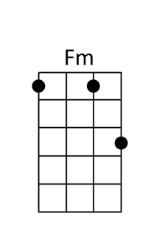

Dreams Fleetwood Mac
[F] [G] [F] [G]

[F] Now here you [G]go again, you say
[F] you want your free-[G]eedom.
[F] Well who am [G]I to keep you down. [F] [G]
[F] It's only ri-i[G]ight, that you should
[F]play the way you [G]feel it,
But [F]listen careful[G]ly,
to the sou-[F]-ound of your [G]loneliness.

Like a [F]heartbeat.. drives you [G]mad,
In the [F]stillness of re[G]membering what you ha-[F]-ad... [G]
And what you lo-[F]-ost... [G]
and what you ha-[F]-ad... [G]
And what you lo-[F]-ost... [G]

Oh, [Am]thunder only [G]happens when it's [F]raining. [G] [Am]Players only [G]love you when they're [F]playing. [G]
Say, [Am]women... they will [G]come and they will [F]go-oh-oh-oh [G]
[Am]When the rain wa-[G]-shes you clean
you'll [F]know, [G]
you’ll [F]know..[G]
[F] [G]

[F] Now here I [G]go again, I see…
[F]…the crystal vi-i-[G]-isions.
[F] I keep my [G]visions to my[F]self. [G]
[F] It's o-o-only me-e-e-[G]e-e, Who wants to
[F]wrap around your [G]dreams and...
[F]Have you any [G]dreams you'd like to [F]sell?
Dreams of [G]lone-li-ness,

like a [F]heartbeat drives you [G]mad,
In the [F]stillness of re[G]membering what you ha-[F]-ad...
[G] And what you lo-[F]-ost...[G] and what you ha-[F]-ad...
[G] Ooh, what you lo-[F]-ost...[G]

[Repeat Chorus]
Oh, [Am]thunder only [G]happens when it's [F]raining. [G] [Am]Players only [G]love you when they're [F]playing. [G]
Say, [Am]women... they will [G]come and they will [F]go-oh-oh-oh [G] [Am]When the rain wa-[G]shes you clean, you'll [F]know…[G]
You’ll [F]know…[G]
you will [F]know, [G]Ah-ah-ah-whoa, you’ll [F↓]know

End Of The Line Traveling Wilburys
[F] [C] [F] [G7] [C] [F] [G7] [C] [G7] [C]

[C] Well it's all right riding a [G7] round in the [F] breeze
Well it's [C] all right if you live the [G7] life you [C] please
[C] Well it's all right doing the [G7] best you [F] can
Well it's [C] all right as long as you [G7] lend a [C] hand
[F] You can sit around and wait for the [C] phone to ring
(at the end of the line)
[F] Waiting for someone to tell you [C] everything
(at the end of the line)
[F] Sit around and wonder what to [C] morrow will bring
(at the end of the line)
Maybe a [G7] diamond ring

Well it's [C] all right even if they [G7] say you're [F] wrong
Well it's [C] all right sometimes you [G7] gotta be [C] strong
[C] Well it's all right as long as you got [G7] somewhere to [F] lay
Well it's [C] all right everyday is [G7] judgment [C] day
[F] Maybe somewhere down the [C] road aways
(at the end of the line)
[F] You'll think of me wonder where I [C] am these days
(at the end of the line)
[F] Maybe somewhere down the road when [C] somebody plays
(at the end of the line)
[G7] Purple haze

Well it's [C] all right even when [G7] push comes to [F] shove
Well it's [C] all right if you got [G7] someone to [C] love
[C] Well it's all right everything'll [G7] work out [F] fine
Well it's [C] all right we're going to the [G7] end of the [C] line
[F] Don't have to be ashamed of the [C] car I drive
(at the end of the line)
[F] I'm glad to be here happy to [C] be alive
(at the end of the line)
[F] It don't matter if you're [C] by my side
(at the end of the line)
I'm [G7] satisfied

Well it's [C] all right even if you're [G7] old and [F] gray
Well it's [C] all right you still got [G7] something to [C] say
[C] Well it's all right remember to [G7] live and let [F] live
Well it's [C] all right the best you can [G7] do is for [C] give

[C] Well it's all right riding a [G7] round in the [F] breeze
Well it's [C] all right if you live the [G7] life you [C] please
[C] Well it's all right even if the [G7] sun don't [F] shine
Well it's [C] all right we're going to the [G7] end of the [C] line

Everybody Wants to Rule the World Tears for Fears
[A7..G] [A7..G] [A7..G]  Welcome to your [A7..] li[G]fe  there's no turning [A7..] ba[G]ck  Even while we [A7..] sle[G]ep we will find you  [Em] Acting on your [F#m] best behaviour  [G] Turn your back on [F#m] mother nature  [Em] Every[F#m]body [G] wants to [A] rule the [A7..] wo[G]rld  [A7..G] [A7..G]  It's my own de[A7..]si[G]gn  it's my own re[A7..]mo[G]rs  Help me to de[A7..]ci[G]de help me make the  [Em] Most of freedom [F#m] and of pleasure  [G] Nothing ever [F#m] lasts forever  [Em] Every[F#m]body [G] wants to [A] rule the ...  [G] There's a room where the [D] light won't find you  [G] Holding hands while the [D] walls come tumbling [G] down  When they do I'll be [D] right behind you  [Em] So glad we [F#m] almost made it  [G] So sad they [F#m] had to fade it  [Em] Every[F#m]body [G] wants to [A] rule the [D] world  [A7..G] [A7..G]  [Em] I can't stand this [F#m] indecision  [G] Married with a [F#m] lack of vision  [Em] Every[F#m]body [G] wants to [A] rule the ...  [Em] Say that you'll [F#m] never need it  [G] One headline [F#m]why believe it  [Em] Every[F#m]body [G] wants to [A] rule the …  [Em] All for freedom [F#m] and for pleasure  [G] Nothing ever [F#m] lasts forever  [Em] Every[F#m]body [G] wants to [A] rule the [A7..] wo[G]rld  [A7..G] [A7..G] [A7..G] | 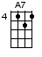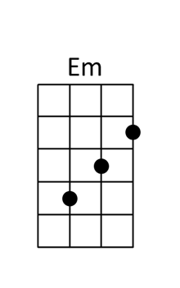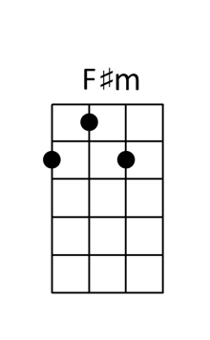

Exes and Oh’s Elle King
[Em] [G] [Em] [B]  Well, I [Em]had me a [G]boy, turned him [Em]into a [B]man  I [Em]showed him all the [G]things that he [Em]didn't unders[B]tand  Who[B7]a, and then I let him [Em]go [G] [Em] [B]  Now, there's [Em]one in Cali[G]fornia who's been  [Em]cursing my [B]name  'Cause [Em]I found me a [G]better lover [Em]in the U.[B]K.  Hey, [B7]hey, until I made my geta[Em]way [G] [Em] [B]  [Em]One, two, three, they gonna run back to me  'Cause I'm the best baby that they never gotta keep  One, two, three, they gonna run back to me  They [Em↓]always wanna come, but they never wanna leave  [G]Ex's and the o[D]h, oh, oh's they [Em]haunt me  Like [B]ghosts they [G]want me to make 'em [D]all  They[Am] won't let [C]go  Ex's and [Em]oh's [G] [Em] [B] [Em] [G] [Em] [B]  I [Em]had a summer [G]lover down in [Em]New Or[B]leans  Kept him [Em]warm in the [G]winter, left him  [Em]frozen in the [B]spring  My, [B7]my, how the seasons go [Em]by [G] [Em] [B]  [Em]I get hi[G]gh, and I [Em]love to get [B]low  So the [Em]hearts keep [G]breaking, and the [Em]heads just [B]roll  You kn[B7]ow that's how the story [Em]goes [G] [Em] [B]  [Em]One, two, three, they gonna run back to me  'Cause I'm the best baby that they never gotta keep  One, two, three, they gonna run back to me  They [Em↓]always wanna come, but they never wanna leave  [G]Ex's and the o[D]h, oh, oh's they [Em]haunt me  Like g[B]hosts they [G]want me to make 'em [D]all  They[Am] won't let [C]go  Ex's and [Em]oh's [G] [Em] [B] [Em] [G] [Em] [B] [Em↓]  [G]Ex's and the o[D]h, oh, oh's they [Em]haunt me  Like [B]ghosts they [G]want me to make 'em [D]all  They[Am] won't let [C]go  Ex's and [Em]oh's [G] [Em] [B] [Em] [G] [Em] [B] [Em↓] | 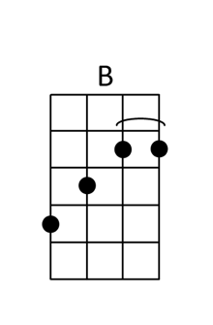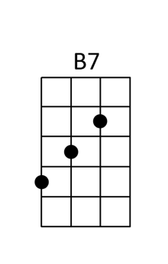

Feel It Still Portugal. The Man
[C#m] [E] [F#m] [C#m]  Can't keep my hands to myself [C#m]  [E] Think I'll dust em off, put em back up on the [F#m] shelf  In case my little baby girl is in [C#m] need  Am I coming out of left field?  CHORUS  [C#m] Ooh woo, I'm a rebel just for kicks now  [E] I been feeling it since 1966 now  [F#m] Might be over now, but I feel it [C#m] still  REPEAT CHORUS  [no chord] Got another mouth to feed [C#m]  [E] Leave her with a baby sitter,  mama call the grave digger [F#m]  Gone with the fallen leaves [C#m]  Am I coming out of left field?  REPEAT CHORUS  REPEAT CHORUS  We could fight a war for peace [A] [F#m]  [C#m] Give in to that easy living goodbye to my hopes and  [A] dreams. Stop [F#m] flipping for my enemies [C#m]  We could [C#m] wave until the walls come [A] down [F#m]  [C#m] It's time to give a little tip kids in the middle move  [A] over till it [F#m] falls Don't bother me [C#m]  [A] Is it coming [F#m] Is it coming [C#m] Is it coming [C#m]  Is it coming [A] Is it coming [F#m] Is it coming [C#m] back?  REPEAT CHORUS  REPEAT CHORUS  [C#m] Ooh woo, I'm a rebel just for kicks now  [E] Let me kick it like it's 1986 now  [F#m] Might be over now, but I feel it [C#m] still  Might’ve had your fill, but you feel it still [C#m↓] | 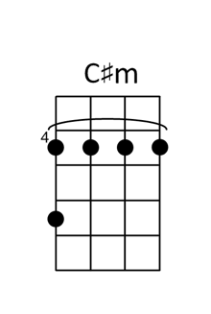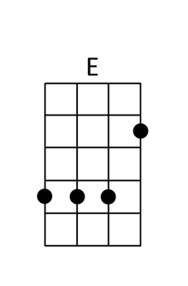

Fire and Rain James Taylor
[C] [Gm] [F] [C] [C] [G] [Bb]  [C]Just yesterday [Gm]mornin'  they let me [F]know you were gone[C] [Csus4] [C]  Suzanne the [G]plans they made put an  [Bb]end to you[Bbadd9] [C]  I walked out this [Gm]morning and I  [F]wrote down this song[C] [Csus4] [C]  I just can't [G]remember who to [Bb]send it to  CHORUS  [F]I've seen [Dm]fire and [G]I've seen [C]rain [Csus4] [C]  I've seen [F]sunny days that I  [Dm]thought would [G]never [C]end [Csus4] [C]  I've seen [F]lonely times when I  [Dm]could not [G]find a [C]friend [Csus4] [C]  But I [Bb]always thought that I'd [Gm]see you again [C]  Won't you [C]look down upon me [Gm]Jesus  you've got to [F]help me make a [C]stand  You've just got to [G]see me through a[Bb]nother day [Bbadd9] [C]  My body's [Gm]aching and my [F]time is at hand [C]  I won't [G]make it any [Bb]other way [Bbadd9]  REPEAT CHORUS  Been [C]walking my mind to an [Gm]easy time  my [F]back turned towards the sun [C] [Csus4] [C]  Lord knows when the [G]cold wind blows  it'll [Bb]turn your head around [Bbadd9]  Well there's [C]hours of time on the [Gm]telephone line  to [F]talk about things to come [C] [Csus4] [C]  Sweet dreams and [G]flying machines  in [Bb]pieces on the ground [Bbadd9]  REPEAT CHORUS EXCEPT FOR LAST LINE  But I [Bb]always thought that I'd [Gm]see you baby  [C]one more time a[C7]gain now  Thought I'd see [Bb]you one more [Gm]time a[C]gain  There's just a [Bb]few things coming my  [Gm]way this time a[C]round now  Thought I'd see [Bb]you thought I'd see  [Gm]you fire and rain now  Na na na [Bb]Na na na na [Gm]Na [C]Na | 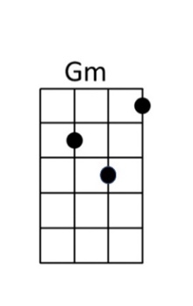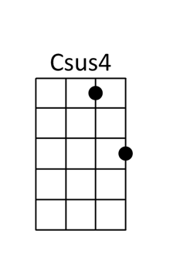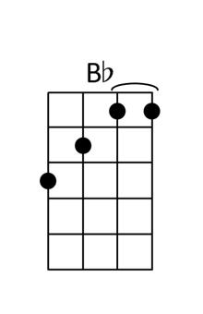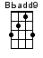

Flowers Miley Cyrus
[Cmaj7] <arpeggio up>  We were [Am]good, we were [Dm]gold,  Kind of [G]dream that can't be [C]sold  We were [Am]right 'til we [Dm]weren't,  Built a [G]home and watched it [C]burn  Mmm, [Am]I didn't wanna leave you, [Dm]I didn't wanna lie  [E7]Started to cry but then remembered, I  CHORUS  [Am]I can buy myself [Dm]flowers, [G]Write my name in the [C]sand  [Am]Talk to myself for [Dm]hours, [G]Say things you don't under[C]stand  [Am]I can take myself [Dm]dancing, [G]And I can hold my own [C]hand  Yeah, I can [F]love me better [E7/]than.. you [Am]can  [Am]Can love me better, [Dm]I can love me better, baby  [G]Can love me better, [C]I can love me better  Paint my [Am]nails, cherry [Dm]red,  Match the [G]roses that you [C]left  No [Am]remorse, no [Dm]regret,  I for[G]give every word you [C]said  Ooh, [Am]I didn't wanna leave you, [Dm]I didn't wanna fight  [E7]Started to cry but then remembered, I  REPEAT CHORUS  Can love me better, [Dm]I can love me better, baby  [G]Can love me better, [C]I can love me better, baby  [Am]Can love me better, [Dm]I can love me better, baby  [G]Can love me better, [C]I..  [Am↓]I didn't wanna leave you, [Dm↓]I didn't wanna fight  [E7↓]Started to cry but then remembered, I..  REPEAT CHORUS EXCEPT LAST LINE  Yeah, I can [F]love me better [E7]than  Yeah, I can [F]love me better [E7↓]than, you [Am]can  Can love me better, [Dm]I can love me better, baby  [G]Can love me better, [C]I can love me better, baby  [Am]Can love me better, [Dm]I can love me better, baby  [G]Can love me better, [C↓]I.. | 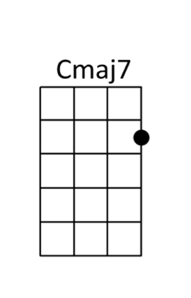

Fly Me To the Moon Frank Sinatra
[Am] [Am]

[Am] Fly me to the [Dm] moon, and let me
[G7] play among the [Cmaj7] stars [C7]
[F] Let me see what [Dm] spring is like on
[E7] Jupiter and [Am] Mars [A7]

In [Dm] other words, [Dm] [G7] hold my [Em7] hand. [Am]
In [Dm] other words, [G7] baby [Cmaj7] kiss me. [Bm7] [E7]

[Am] Fill my heart with [Dm] song, and let me
[G7] sing forever [Cmaj7] more [C7]
[F] You're all that I [Dm] long for, all I
[E7] worship and a-[Am]dore. [A7]

In [Dm] other words, [G7] please be [Em] true! [A7]
In [Dm] other words, [G7] I love [C6] you! [E7]

Instrumental
[Am] Fill my heart with [Dm] song, and let me
[G7] sing forever [Cmaj7] more [C7]
[F] You are all I [Dm] long for, all I
[E7] worship and do a-[Am]dore.[A7]

[Dm] In other words, [G7] please be [Em] true! [A7]
[Dm] In other words, [G7] I love [C6] you! [E7]

[Am] Fill my heart with [Dm] song, and let me
[G7] sing forever [Cmaj7] more [C7]
[F] You're all that I [Dm] long for, all I
[E7] worship and do a-[Am]dore.[A7]

In [Dm] other words, [G7] please be [Em] true! [A7]
In [Dm] other words, [G7] in other words,
[F] I [G7] love ..... [C] you! [Fm] [C]

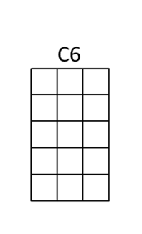

Folsom Prison Blues Johnny Cash
[D] [D] [D] [D]

I [D]hear the train a comin', it's rolling 'round the bend
And I ain't seen the sunshine since I [D7]don't know when
I'm [G7]stuck in Folsom prison,and time keeps draggin' [D]on
But that [A7]train keeps a rollin' on down to San An[D]tone

When [D]I was just a baby my mama told me, "Son
Always be a good boy, don't [D7]ever play with guns"
But I [G7]shot a man in Reno just to watch him [D]die
When I [A7]hear that whistle blowing,
I hang my head and [D]cry

I [D]bet there's rich folks eating in a fancy dining car
They're probably drinkin' whisky and [D7]smoking big cigars
Well I [G7]know I had it coming, I know I can't be [D]free
But those [A7]people keep a-movin'
And that's what tortures [D]me

Well if they [D]freed me from this prison
If that railroad train was mine
I bet I'd move it on a little fur[D7]ther down the line
[G7]Far from Folsom prison, that's where I want to [D]stay
And I'd [A7]let that lonesome whistle
blow my blues a[D]way [D↓] [A7↓] [D↓]

Friend Of the Devil Grateful Dead
G C  A|-10-10--9--9--7--7-------|--3--3--2--2--0--0-------|  E|--7-----7-----7----10-10-|--0-----0-----0--3--3----|  C|--7-----7-----7-----7----|--0-----0-----0-----0----| x2  G|--7-----7-----7-----7----|--0-----0-----0-----0----|  [G]I lit out from Reno, I was [C]trailed by twenty hounds  [G]Didn't get to sleep last night 'till the [C]morning came around.  [D]Set out runnin' but I take my time A [Am]friend of the devil is a friend of mine  If [D]I get home before daylight, I [Am]just might get some sleep to[D]night.  [Am7↓] [Db↓] [D]  [G]Ran into the devil, babe, he [C]loaned me twenty bills  I [G]spent the night in Utah in a [C]cave up in the hills.  [D]Set out runnin' but I take my time A [Am]friend of the devil is a friend of mine  If [D]I get home before daylight, I [Am]just might get some sleep to[D]night.  [Am7↓] [Db↓] [D]  I [G]ran down to the levee but the [C]devil caught me there  He [G]took my twenty dollar bill and [C]vanished in the air.  [D]Set out runnin' but I take my time A [Am]friend of the devil is a friend of mine  If [D]I get home before daylight, I [Am]just might get some sleep to[D]night.  [Am7↓] [Db↓] [D]  [D]Got two reasons why I cry away each lonely night,  The [C]first one's named Sweet Anne Marie, and she's my hearts delight.  The [D]second one is prison, babe, the sheriff's on my trail,  And [Am]if he catches up with me, I'll [C]spend my life in [D]jail.  [G]Got a wife in Chino, babe, and [C]one in Cherokee  The [G]first one says she's got my child, but [C]it don't look like me.  [D]Set out runnin' but I take my time A [Am]friend of the devil is a friend of mine  If [D]I get home before daylight, I [Am]just might get some sleep to[D]night.  [Am7↓] [Db↓] [D]  [D]Got two reasons why I cry away each lonely night,  The [C]first one's named Sweet Anne Marie, and she's my hearts delight.  The [D]second one is prison, babe, the sheriff's on my trail,  And [Am]if he catches up with me, I'll [C]spend my life in [D]jail.  [G]Got a wife in Chino, babe, and [C]one in Cherokee  The [G]first one says she's got my child, but [C]it don't look like me.  [D]Set out runnin' but I take my time A [Am]friend of the devil is a friend of mine  If [D]I get home before daylight, I [Am]just might get some sleep to[D]night.  [Am7↓] [Db↓] [D↓] | 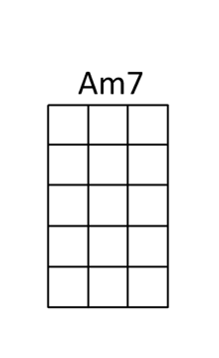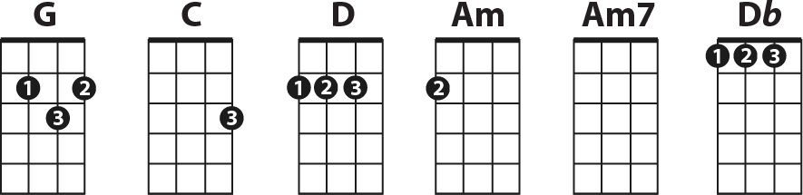

Friends In Low Places Garth Brooks
[A] [Bbdim] [Bm7][ E]  Blame it [A] all on my roots  I [Bbdim] showed up in boots  and[Bm] ruined your black tie affair  The [E] last one to know,  the [E7] last one to show I was the  [A] last one you thought you'd see there  And I [A] saw the surprise  and the [Bbdim] fear in his eyes when  [Bm] I took his glass of champagne  [E] I toasted you, said honey  [E7] we may be through  but you'll never hear me complain  CHORUS  'Cause [A] I got friends in low places where the  whiskey drowns and the beer chases  My [Bm] blues away and I'll [E] be okay  Now [A] I'm not big on social graces, think I'll  slip on down to the ‘Oasis’  So [Bm] I've got friends [E] in low [A] places  Well I [A] guess I was wrong  I [Bbdim] just don't belong  but [Bm] then, I've been there before  Every[E] thing's alright  I'll [E7] just say goodnight And I'll  [A] show myself to the door  Hey [A] I didn't mean  to [Bbdim] cause a big scene  just [Bm] give me an hour and then  [E] I'll be as high as that  [E7] ivory tower that you’re livin’ in  REPEAT CHORUS  REPEAT CHORUS | 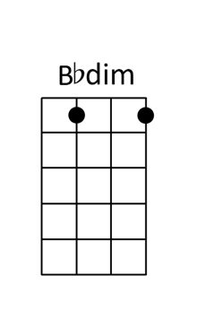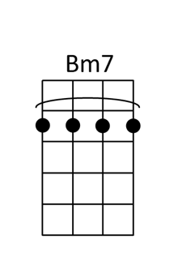

The Gambler Kenny Rogers
On a [D] warm summer's evenin'on a [G] train bound for [D] nowhere,
I met up with the gambler; we were both too tired to [A] sleep.
So [D] we took turns a starin' out the [G] window at the [D] darkness
'til [G] boredom over [D] took us, and [A] he began to [D] speak.

He said, [D] "Son, I've made a life out of [G] readin' people's [D] faces,
and knowin' what their cards were by the way they held their [A] eyes.
And if [D] you don't mind my sayin', I can [G] see you're out of [D] aces.
For a [G] taste of your [D] whiskey I'll [A] give you some [D] advice."

So I [D] handed him my bottle and he [G] drank down my last [D] swallow.
Then he bummed a cigarette and asked me for a [A] light.
And the [D] night got deathly quiet, and his [G] face lost all ex[D]pression.
Said, "If you're [G] gonna play the [D] game, boy,
ya gotta [A] learn to play it [D] right.

CHORUS
You got to [D] know when to hold 'em, [G] know when to [D] fold 'em,
[G] know when to [D] walk away and know when to [A] run.
You never [D] count [Em] your [D] money when you're [G] sittin' at the [D] table.
There'll be [G] time enough for [D] countin' [A] when the dealin's [D] done.

[D] Ev'ry gambler knows that the [G] secret to surv[D]ivin'
is knowin' what to throw away and knowing what to [A] keep.
'Cause [D] ev'ry hand's a winner and [G] ev'ry hand's a [D] loser,
and the [G] best that you can [D] hope for is to [A] die in your [D] sleep."

And [D] when he'd finished speakin', he [G] turned back towards the [D] window,
crushed out his cigarette and faded off to [A] sleep.
And [D] somewhere in the darkness the [G] gambler, he broke [D] even.
But [G] in his final [D] words I found an [A] ace that I could [D] keep.

REPEAT CHORUS A CAPELLA
REPEAT CHORUS

Goodbye Earl Chicks (Dixie Chicks)

INTRO 2x
C↓ ↓ ↓↑↓ F ↓ ↓ C ↓ ↓ G ↓ ↓ ↓↑↓ F ↓ ↓ ↓↑↓
1 2 3&4 1 2 1 2 1 2 3&4 1 2 3&4
C F
Mary Anne and Wanda were the best of friends
C G
All through their high school days
C F
Both members of the 4H Club
C G C
Both active in the FFA
C F
After graduation Mary Anne went out
C G
lookin' for a bright new world
C F
Wanda looked all around this town
C G C C
And all she found was Earl
C
Well, it wasn't two weeks
F
After she got married that
C G
Wanda started gettin' abused
C F
She put on dark glasses and long sleeved blouses
C G C
And make up to cover a bruise
C F
Well, she finally got the nerve to file for divorce
C G
She let the law take it from there
C
But Earl walked right through that
F
restraining order
C G C C
And put her in intensive care
Am G
Right away Mary Anne flew in from Atlanta
F C
On a red eye midnight flight
Am
She held Wanda's hand as they
G
Worked out a plan
F G↓↓↓
And it didn't take 'em long to decide
C F C G F
That Earl had to die Goodbye Earl
C
Those black-eyed peas
F C G F
They tasted all right to me Earl
C
You're feelin' weak
F C G F
Why don't you lay down and sleep Earl
C
Ain't it dark
F C G F
Wrapped up in that tarp Earl
C↓ F↓ G↓ F↓
C↓ F↓
The cops came by to bring Earl in
C↓ G↓
They searched the house high and low
C↓
Then they tipped their hats and said
F↓ C↓
"thank you ladies, if you hear from him
G↓ C↓
let us know"
C
Well, the weeks went by and
F
Spring turned to Summer
C G
And Summer faded into Fall
C F
And it turns out he was a missing person
C G C C
Who nobody missed at all
Am
So the girls bought some land
G
And a roadside stand
F C
Out on Highway 109
Am
They sell Tennessee ham
G F
And strawberry jam and they don’t
G↓↓↓
Lose any sleep at night
C F C G F
‘cause Earl had to die Goodbye Earl
C↓
We need a break [break]
F C G F
Let's go out to the lake Earl
C
We'll pack a lunch
F C G F
And stuff you in the trunk Earl
C
Well, is that all right
F C G F
Good, let's go for a ride Earl..Hey!
C F C G F
Na na na na na na..na..na..na.. [x3]
C↓F↓C↓G↓ C↓F↓C↓G↓ ↓↓↓

Handle With Care Traveling Wilburys
INTRO
1 2 3 4 / [D] [C] / [G] / [D] [C] / [G] /

[D] Been beat [C] up and [G] battered around
[D] Been set [C] up and I've [G] been shut down
[C] You're the best thing that [G] I’ve ever [Em] found
[C] Handle [D] me with [G] care

[D] Repu-[C]tations [G] changeable
[D] Situ-[C]ations [G] tolerable
[C] But baby you're a-[G]dora-[Em]ble
[C] Handle me with [D] care [D7]

[G] I'm so [B7] tired of [C] being [D] lonely
[G] I still [B7] have some [C] love to [D] give
[G] Won't you [B7] show me [C] that you [D] really [G] care [G]

Every-[C]body's got somebody to [G] lean [G] on
Put your [C] body next to mine and [D] dream [D] on

[D] I've been fobbed [C] off and I've [G] been fooled
[D] I've been [C] robbed and [G] ridiculed
In [C] daycare centers and [G] night [Em] schools
[C] Handle [D] me with [G] care

[D][C] / [G] / [D][C] / [G] /

[D] Been stuck in [C] airports [G] terrorized
[D] Sent to [C] meetings [G] hypnotized
[C] Overexposed com-[G]mercial-[Em]ized
[C] Handle me with [D] care [D7]

[G] I'm so [B7] tired of [C] being [D] lonely
[G] I still [B7] have some [C] love to [D] give
[G] Won't you [B7] show me [C] that you [D] really [G] care [G]

Every-[C]body's got somebody to [G] lean [G] on
Put your [C] body next to mine and [D] dream [D] on

I've [D] been up [C] tight and [G] made a mess
But [D] I'm cleaning [C] up my [G] self I guess
[C] Oh the sweet [G] smell of suc-[Em]cess
[C] Handle [D] me with [G] care [G↓]

Happy Together (Lead Vocals) Turtles
[Am] [Am] [Am] [Am]

Imagine [Am] me and you, I do
[Am] I think about you [G] day and night, it's only right
To think about the [F] girl you love, and hold her tight
So happy to-[E7]gether [E7]

If I should [Am] call you up, invest a dime
And you say you be-[G]long to me, and ease my mind
Imagine how the [F] world could be, so very fine
So happy to-[E7]gether [E7]

[A] I can't see me [Em] lovin' nobody but [A] you, for all my [G] life
[A] When you're with me [Em] baby the skies'll be
[A] blue, for all my [G] life

[Am] Me and you, and you and me
No matter how they [G] toss the dice, it had to be
The only one for [F] me is you, and you for me
So happy to-[E7]gether [E7]

[A] I can't see me [Em] lovin' nobody but [A] you, for all my [G] life
[A] When you're with me [Em] baby the skies'll be
[A] blue, for all my [G] life

[Am] Me and you, and you and me
No matter how they [G] toss the dice, it had to be
The only one for [F] me is you, and you for me
So happy to-[E7]gether [E7]

[A] Bah bah bah bah [Em] ba-ba-ba-bah,
ba-ba [A] bah, ba-ba-ba [G] baaah
[A] Bah bah bah bah [Em] ba-ba-ba-bah,
ba-ba [A] bah, ba-ba-ba [G] baa-[G]aaah

[Am] Me and you, and you and me
No matter how they [G] toss the dice, it had to be
The only one for [F] me is you, and you for me
So happy to-[E7]gether [Am]
So happy to-[E7]gether [Am]
how is the [E7] weather [Am]
So happy to-[E7]gether [Am]
we're happy to-[E7]gether [Am]
happy to-[E7]gether
[Am] so happy to-[E7]gether [A↓]

Happy Together (Backup Vocals) Turtles
[Am] / [Am] / [Am] / [Am]

Imagine [Am] me and you, I do
[Am] I think about you [G] day and night, it's only right
To think about the [F] girl you love, and hold her tight
So happy to-[E7]gether [E7]

[Am] Call you [Am] up
[G] ease my [G] mind
[F] Very [F] fine
[E7] [E7]

[A] Aaaah [Em] aaaah [A] aaaah, ba-ba-ba [G] baaaah
[A] Aaaah [Em] aaaah
[A] aaaah, ba-ba-ba [G] baaaah

[Am] You and me
G] had to be
[F] You for me
[E7] [E7]

[A] Aaaah [Em] aaaah [A] aaaah, ba-ba-ba [G] baaaah
[A] Aaaah [Em] aaaah
[A] aaaah, ba-ba-ba [G] baaaah

[Am] Me and you, and you and me
No matter how they [G] toss the dice, it had to be
The only one for [F] me is you, and you for me
So happy to-[E7]gether [E7]

[A] Baaah, baaah [Em] baaah,
ba-ba [A] baaah, ba-ba-ba [G] baaah
[A] Baaah, baaah [Em] baaah,
ba-ba [A] baaah, ba-ba-ba [G] baaa-[G]aah

[Am] Aah, aah [Am] aaaah
[G] Aah, aah [G] aaaah
[F] Aah, aah [F] aaaah
[E7] Oo-oo-oo-[Am]oooo
[E7] Oo-oo-oo-[Am]oooo
[E7] Bah, bah-bah-bah [Am] bah, bah-bah-bah
[E7] Bah, bah-bah-bah [Am] bah, bah-bah-bah
[E7] Bah, bah-bah-bah [Am] bah, bah-bah-bah
[E7] Bah, bah-bah-bah [Am] bah, bah-bah-bah
[E7] Bah, bah-bah-bah [Am] bah, bah-bah-bah
[E7] Bah, bah-bah-bah [Am] bah, bah-bah-bah [A↓] baaah

Harvest Moon Neil Young
G..G6..GM7 G..G6..GM7 G..G6..GM7 G..G6..GM7  C Am CM7  Come a little bit closer  (G..G6..GM7)x2  Hear what I have to say  C Am CM7  Just like children sleepin  Am (G..G6..GM7)x2  We could dream this night away.  C Am CM7  But there’s a full moon risin  Am (G..G6..GM7)x2  Let’s go dancin in the light  C Am CM7  We know where the music’s playin  Am (G..G6..GM7)x2  Let’s go out and feel the night.  CHORUS  C D  Because I’m still in love with you,  Am  I want to see you dance again.  C D↓  Because I’m still in love with you  (G..G6..GM7)x2  On this harvest moon.  C Am CM7 Am (G..G6..GM7)x2  When we were strangers I watched you from afar  C Am CM7  When we were lovers  (G..G6..GM7)x2  I loved you with all my heart.  C Am CM7  But now its gettin late  Am (G..G6..GM7)x2  And the moon is climbin high  C Am CM7 Am (G..G6..GM7)x2  I want to celebrate. See it shinin in your eye.  REPEAT CHORUS  (G..G6..GM7) G↓ | 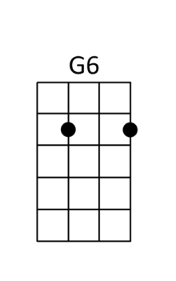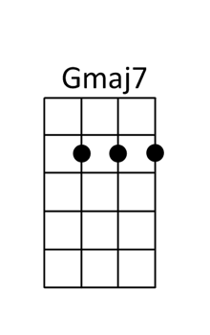

Hey Soul Sister Train
[G] [G] Hey [D] ay Hey ay ay [Em] ay Hey ay ay [C] ay
Your [G] lipstick stains [D] on the front lobe of my
[Em] left side brains [C]
I knew I wouldn't for[G]get you
And so I went and [D] let you blow my [Em] mind [C] [D]

Your [G] sweet moonbeam
[D] The smell of you in every [Em] single dream I [C] dream
I knew when we co[G]llided you're the one I have de[D]cided
Who's one of my [Em] kind [C] [D]

CHORUS
[C] Hey soul sister [D] ain't that mister
[G] mister [D] on the [C] radio stereo
The [D] way you move ain’t [G] fair you [D] know
[C] Hey soul sister [D] I don't want to
[G] miss a [D] single [C] thing you do [D↓] To[G]night

[G] Hey [D] ay Hey ay ay [Em] ay Hey ay ay [C] ay

[G] Just in time [D] I'm so glad you have a
[Em] one track mind like [C] me
You gave my love dir[G]ection
a game show love co[D]nnection
We can't de[Em]ny [C] [D]

I'm [G] so obsessed [D] my heart is bound to beat
Right [Em] outta my untrimmed [C] chest I believe in [G] you
Like a virgin you're Ma[D]donna
And I'm always gonna [Em] wanna blow your [C] mind [D]

REPEAT CHORUS

[G] The way you can't cut a rug
[D] watching you's the only drug I [Em] need
You're so gangster I'm so thug you're the
[C] only one I'm dreaming of you [G] see
I can be myself now fina[D]lly in fact there's
nothing I can't [Em] be. I want the world to see you
[C] be with [D] me

REPEAT CHORUS
Hey [D] ay Hey ay ay [Em] ay Hey ay ay [C] ay [D]
To[G]night

Hold Me Now Thompson Twins
[D] [Bm] [C] [A7]

[D]I have a picture
[Bm]Pinned to my wall
An [C]image of you and of me and we're
laughing with [A7]love at it all

[D]Look at our life now.
[Bm]Tattered and torn
[C]We fuss and we fight and delight in the
tears that we [A7]cry until dawn

CHORUS
[D]Hold me now [Bm]Warm my heart
[C]Stay with me. Let the [A7]loving start, let loving start

You [D]say I'm a dreamer.
We're [Bm]two of a kind
[C]Both of us searching for some perfect
Place We know [A7]we'll never find

So per[D]haps I should leave here
Yeah [Bm]Go far away
But you [C]know that there's nowhere that I'd rather be
Than with [A7]you here today Ooh Oh Ooh Oh

REPEAT CHORUS
REPEAT CHORUS

[Bb] ohh [C] Ohh [Bb] Ohh [C] Ohh [Bb] Ohh [C] Ohh

You [D]asked if I love you
[Bm]What can I say
[C]You know that I do and that this is just
one of those [A7]Games that we play

So I'll [D]sing you a new song
Please don't [Bm]cry any more
I'll even [C]ask your forgiveness though I don't know
Just what I'm [A7]asking it for Ooh Oh Ooh Oh

REPEAT CHORUS
REPEAT CHORUS
[D↓]

Home For A Rest Spirit of the West
<Slow> You'll [Em]have to ex-[D]cuse me, I'm [G]not at my [C]best
I've been [G]gone for a [D]month
I've been [C↓]drunk [G↓]since [Am7↓]I [G↓]left

You'll [Em]have to ex-[D]cuse me, I'm [G]not at my [C]best
I've been [G]gone for a [D]month
I've been [C↓]drunk [G↓]since [Am7↓]I [G↓]left
These [Em]so-called va-[D]cations
will [G]soon be my [C]death I'm so [G]sick from the [D]drink
I need [C↓]home [G↓]for [Am7↓]a [G↓]rest

<Faster> We ar-[Em]rived in De-[D]cember and [G]London was [C]cold
We [G]stayed in the [D]bars along [C]Charing Cross Road
We [Em]never saw [D]nothin' but [G]brass taps and [C]oak
Kept a [G]shine on the [D]bar with the [C]sleeves of our [D]coats

CHORUS
You'll [D↓]have to excuse me, I'm [G↓]not at my [D↓]best
I've been [G]gone for a [C]week, I've been [D]drunk since I left
And these [D↓]so-called vacations will [G↓]soon be my [D↓]death
I'm so [G]sick from the [C]drink, I need [D]home for a [C]rest
Take me [Em]home

[Am7] | [D] | [Bm↓][Em↓] | [Em] | [Am7] | [D] | [Bm↓][Em↓] |

[Em]Euston [D]Station the [G]train journey [C]North
[G]In the buffet [D]car we [C]lurched back and forth
Past [Em]old crooked [D]dykes through [G]Yorkshire's green [C]fields
We were [G]flung into [D]dance as the [C]train jigged and [D]reeled

REPEAT CHORUS
[C] | [D] | [Am7] | [Em] | [C] | [D] | [D] |
[Em] | [Am7] | [D] | [Bm] |
[Em] | [Am7] | [D] | [D] | [B] | [B]

By the [Em]light of the [D]moon, she'd [G]drift through the [C]streets
A [G]rare old per-[D]fume, so se-[C]ductive and sweet
She'd [Em]tease us and [D]flirt, as the [G]pubs all closed [C]down
Then [G]walk us on [D]home and de-[C]ny us a [D]round
REPEAT CHORUS
[Am7] | [D] | [Bm↓][Em↓] | [Em] | [Am7] | [D] | [Bm↓][Em↓]/

The [Em]gas heater's [D]empty, it's [G]damp as a [C]tomb
The [G]spirits we [D]drank, now [C]ghosts in the room
I'm [Em]knackered a-[D]gain, come on [G]sleep take me [C]soon
And don't [G]lift up my [D]head 'till the [C]twelve bells at [D]noon

REPEAT CHORUS except last two lines
<Slow> I'm so [G]sick from the [C]drink I need [D]home for a [G]rest

Hotel California Eagles
[Am] [E7] [G] [D] [F] [C] [Dm] [E7]

[Am]On a dark desert highway [E7]cool wind in my hair
[G]Warm smell of colitas [D]rising up through the air
[F]Up ahead in the distance [C]I saw a shimmering light
[Dm]My head grew heavy and my sight grew dim
[E7]I had to stop for the night

[Am]There she stood in the doorway [E7]I heard the mission bell
[G]And I was thinking to myself this could be [D]heaven or this could be hell
[F]Then she lit up a candle [C]and she showed me the way
[Dm]There were voices down the corridor [E7]I thought I heard them say

[F]Welcome to the Hotel Cali[C]fornia
Such a [E7]lovely place such a [Am]lovely face
[F]Plenty of room at the Hotel Cali[C]fornia
Any [Dm]time of year you can [E7]find it here

[Am]Her mind is Tiffany twisted [E7]she got the Mercedes bends
[G]She got a lot of pretty pretty boys [D]that she calls friends
[F]How they dance in the courtyard [C]sweet summer sweat
[Dm]Some dance to remember [E7]some dance to forget

[Am]So I called up the captain [E7]please bring me my wine
He said [G]we haven't had that spirit here since [D]1969
[F]And still those voices are calling from [C]far away
[Dm]Wake you up in the middle of the night [E7]just to hear them say

[F]Welcome to the Hotel Cali[C]fornia
Such a [E7]lovely place such a [Am]lovely face
[F]Plenty of room at the Hotel Cali[C]fornia
Any [Dm]time of year you can [E7]find it here

[Am]Mirrors on the ceiling [E7]the pink champagne on ice
And she said [G]we are all just prisoners here [D]of our own device
[F]And in the master's chambers [C]they gathered for the feast
[Dm]They stab it with their steely knives but they [E7]just can't kill the beast

[Am]Last thing I remember I was [E7]running for the door
[G]I had to find the passage back to the [D]place I was before
[F]Relax said the nightman we are [C]programmed to receive
[Dm]You can check out anytime you like [E7]but you can never leave

[F]Welcome to the Hotel Cali[C]fornia
Such a [E7]lovely place such a [Am]lovely face
They [F]livin' it up at the Hotel Cali[C]fornia
What a [Dm]nice surprise bring your [E7]alibis [Am]

[Am] [E7] [G] [D] [F] [C] [Dm] [E7]
[Am] [E7] [G] [D] [F] [C] [Dm] [E7] [Am]

I’m A Believer Monkees
[G] I thought love was [D] only true in [G] fairy tales,
[G] Meant for someone [D] else but not for [G] me [G7]
[C] Love was out to [G] get me [C] that's the way it [G] seemed,
[C] Disappointment [G] haunted all my [D7] dreams

Then I saw her [G] face [C] [G]
now I'm a be[G]liever [C] [G]
Not a [G] trace [C] [G]
of doubt in my [G] mind [C] [G]
I'm in [G] love (oooooh)
[C] I'm a be[G]liever I couldn't [F] leave her if I [D7] tried

[G] I thought love was [D] more or less a [G] givin thing
[G] It seems the more I [D] gave the less I [G] got [G7]
[C] What's the use in [G] trying [C] all you get is [G] pain
[C] When I needed [G] sunshine I got [D7] rain

Then I saw her [G] face [C] [G]
now I'm a be[G]liever [C] [G]
Not a [G] trace [C] [G]
of doubt in my [G] mind [C] [G]
I'm in [G] love (oooooh)
[C] I'm a be[G]liever I couldn't [F] leave her if I [D7] tried

[G] [D] [G] [G] [D] [G] [G7]

[C] Love was out to [G] get me
[C] that's the way it [G] seemed
[C] Disappointment [G] haunted all my [D7] dreams

Then I saw her [G] face [C] [G]
now I'm a be[G]liever [C] [G]
Not a [G] trace [C] [G]
of doubt in my [G] mind [C] [G]
I'm in [G] love (oooooh)
[C] I'm a be[G]liever I couldn't [F] leave her if I [D7] tried

Yes I saw her [G] face [C] [G]
now I'm a be[G]liever [C] [G]
Not a [G] trace [C] [G]
of doubt in my [G] mind [C] [G]
I'm a be[G]liever [C] [G]

I'm a be[G]liever [C] [G]
<Fade to end>

I’m Yours Jason Mraz
[C] [G] [Am] [F]

Well [C] you done done me and you bet I felt it,
I [G] tried to be chill but you're so hot that I melted,
I [Am] fell right through the cracks,
[F] And now I'm tryin to get back....

Before the [C] cool dun run out, Ill be givin it my bestest
[G] Nothin's gonna stop me but divine intervention
I [Am] reckon its again my turn, to [F] win some or [G] learn some

CHORUS
[C] But I wont hesi-[G]tate, no more, No [Am] more
It can not [F] wait; I'm Yours [C]

Well, [C] open up your mind and see like [G] me,
Open up your plans and damn you're [Am] free.
Look into your heart and you'll find [F] love, love, love, love.

[C] Listen to the music of the moment, people dance and
[G] sing, We're just one big fami-[Am]ly
And it's our God-forsaken right to be [F] loved, loved, loved, loved
[Am] loved [G]

REPEAT CHORUS
[C] There's no need to compli-[G]cate.
Our time is [Am] short, this is our [F] fate, I'm yours.

[C] Do-do-do-do [G] you want to [Am] come on,
[G] scootch on over [F] closer, dear, And I will nibble [Edim] your ear
[Dm] do dee waba bobee [C] dum woooo[G] ooaa
[Am] ooh ohh [G] o oo ooo [F] owww [Em] hhhmm hmm

I've been [C] spending way too long checking my tongue in the mirror
And [G] bending over backwards just to try to see it clearer
But my [Am] breath fogged up the glass
so I [F] drew a new face and I laughed.

I [C] guess what I'll be saying is there ain't no better reason
To [G] rid yourself of vanities and just go with the seasons.
[Am] It's what we aim to do, our [F] name is our vir-[Am]tue.

REPEAT CHORUS

[C] Well, open up your mind and see like [G] me,
Open up your plans and damn you're [Am] free.
Look into your heart and you'll [C] find that this [F] guy is yours.
So [C] please don't, please don't, please don't
There's no [G] need to complicate.
'Cause our [Am] time is short, this is our [F] fate, I'm you..[Em]..rs.

In the Jailhouse Now Soggy Bottom Boys
C | F | G | | C |
A|-------------|-3-2-3-5-3-0-|-0-1-2---------|-1-2-------------|-------------|
E|-3-2-3-5-3-0-|-5-4-5-6-5-1-|-------3-3-2-1-|-----3-3-3-3-2-1-|-3-2-3-5-3-0-|
C|-4-3-4-5-4-0-|-------------|---------------|-----------------|-4-3-4-5-4-0-|
G|-------------|-------------|---------------|-----------------|-------------|
[G] He's in the jailhouse [C] now
He's in the jailhouse [F] now
I [G] told him once or twice
To quit playin' cards and a shootin' dice
He's in the jailhouse [C] now

[C] Well I had a friend named Rambling Bob
Who used to steal gamble and rob
He thought he was the [C7] smartest guy in [F] town
[F] But I found out last Monday
that Bob got locked up Sunday
They [D] got him in the jailhouse way [G] downtown

He's in the jailhouse [C] now
He's in the jailhouse [F] now
I [G] told him once or twice
To quit playin' cards and a shootin' dice
He's in the jailhouse [C] now

yodel-e-o-[C]lay-ee..[C]..o-[F]lay-ee,..[F]..
o-[G]lay-ee-o, o-l[C]ay-ee-o, o-[C↓]lay-ee

[C] Now I went out last Tuesday
I met a girl named Susie
I told her I was the [C7] swellest man [F] around
[F] We started to spend my money
And she started to callin' me honey
We [D] took in every honky tonk in [G] town

We're in the jailhouse [C] now
We're in the jailhouse [F] now
They [G] told us once or twice
To quit playin' cards and a shootin' dice
We're in the jailhouse [C] now [C↓] [G↓] [C↓]

Invisible Touch Genesis
[F] [Bb↓↓] [C↓↓] [F] [Dm↓↓] [C↓↓]

[Dm]Well I’ve been [Bb]waiting,[F] waiting here so [F]long
[Dm]But thinking [Bb]nothing, [F]nothing could go w[C]rong,
ooh [G]now I know [G]
[G]She has a [Bb]built in ability[F] [C↓] [F↓]
To [Bb]take everything she sees[F] [C↓] [F↓]
[Bb] And now it seems I’m falling, [C]falling for her.

[F] She seems to have an [Bb]invisible [C]touch yeah
[F] She reaches in, and [Bb]grabs right hold of [C]your heart
[F] She seems to have an [Bb]invisible [C]touch yeah
[F] It takes control and [Bb]slowly [C]tears you a[Dm]part.

[Dm] Well I don’t really [Bb]know her, I [F]only know her [C]name
[Dm] But when she crawls [Bb]under your skin,
you’re [F]never quite the [C]same, and[G]now I know [G]
[G]She’s got [Bb]something you just can’t trust[F] [C↓] [F↓]
Its [Bb]something mysterious[F] [C↓] [F↓]
[Bb] And now it seems I’m falling, [C]falling for her.

[F] She seems to have an [Bb]invisible [C]touch yeah
[F] She reaches in, and [Bb]grabs right hold of [C]your heart
[F] She seems to have an [Bb]invisible [C]touch yeah
[F] It takes control and [Bb]slowly [C]tears you a[Dm]part.

[Dm]She don’t like [Bb]losing, to [F]her it’s still a [C]game
[Dm]And though she will [Bb]mess up your life,
You’ll [F]want her just the [C]same,
and [G]now I know
[G]She has a [Bb]built in ability[F] [C↓] [F↓]
[Bb]To take everything she sees[F] [C↓] [F↓]
[Bb]And now it seems I’ve fallen, [C]fallen for her.

CHORUS <KEY CHANGE FROM F TO G>
[G]She seems to have an [C]invisible [D]touch yeah
[G]She reaches in, and [Em]grabs right [D]hold of your heart
[G]She seems to have an [C]invisible [D]touch yeah
[G]It takes control and [Em]slowly [D]tears you [G]apart…

REPEAT LAST CHORUS, FADE OUT

It’s Still Rock & Roll To Me Billy Joel
[C] What's the matter with the [Em] clothes I'm wearing?  Can't you [Bb] tell that your tie's too [F] wide?  [C] Maybe I should buy some [Em] old tab collars?  Welcome [Bb] back to the age of [F] jive  [Em] Where have you been hidin' [Am] out lately, honey?  You [Em] can't dress trashy till you [D]spend a lot of [G] money  [C] Everybody's [Em] talkin' 'bout the [Bb] new sound  [F] Funny, but it's [Am] still rock and [G] roll to [C] me [C]  [C] What's the matter with the [Em] car I'm driving?  Can't you [Bb] tell that it's out of [F] style?  [C] Should I get a set of [Em] white wall tires?  Are you [Bb] gonna cruise the miracle [F] mile?  [Em] Nowadays you can't be [Am] too sentimental  Your [Em] best bet's a true baby [D] blue Conti[G]nental  [C] Hot funk, [Em] cool punk, [Bb] even if it's [F] old junk  It's [Am] still rock and [G] roll to [C] me [C]  Oh, [G] it doesn't matter what they [F] say in the papers  Cause it's [E] always been the same old [Am] scene  There's a [G] new band in town but you [F] can't get the sound  from a [E] story in a maga[G#]zine...  [Eb] Aimed at your average [F] teen [G]  [C] How about a pair of [Em] pink sidewinders  And a [Bb] bright orange pair of [F] pants?  [C] You could really be a [Em] Beau Brummel baby  If you [Bb] just give it half a [F] chance  [Em] Don't waste your money on a [Am] new set of speakers  You [Em] get more mileage from a [D] cheap pair of [G] sneakers  [C] Next phase, [Em] new wave, [Bb] dance craze, [F] anyways  It's [Am] still rock and [G] roll to [C] me [C]  [G] [F] [E] [Am] [G] [F] [E] [G#] [Eb] [F] [G↓] Oh……….  [C] What's the matter with the [Em] crowd I'm seeing?  Don't you [Bb] know that they're out of [F] touch?  [C] Should I try to be a [Em] straight 'A' student?  If you [Bb] are then you think too [F] much  [Em] Don't you know about the [Am] new fashion honey?  [Em] All you need are looks and a [D] whole lotta [G] money  It's [C] next phase, [Em] new wave, [Bb] dance craze,  [F] anyways It's [Am] still rock and [G] roll to [C] me  [C↓] Everybody's [Em↓] talkin' 'bout the [Bb↓] new sound  [F↓] Funny, but it's [G↓] still rock and roll to me [x][x][C7↓] | 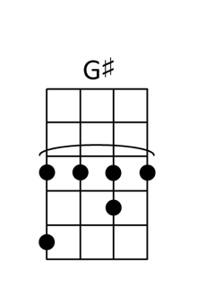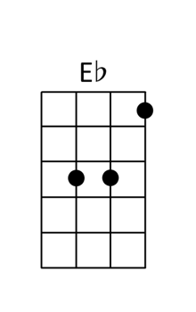

Killing Me Softly Roberta Flack
CHORUS  [Em]Strumming my pain with his [Am]fingers  [D]Singing my life with his [G]words  [Em]Killing me softly with [A]his song  Killing me [D]softly with [C]his song  Telling my [G]whole life with [C]his words  Killing me [Fmaj7]softly  With his [E]song  [Am] I heard he [D]sang a good song  [Gmaj7] I heard he [C]had a style  [Am] And so I [D]came to see him  And [Em]listen for a [Em7]while  [Am] And there he [D]was this young boy  [G] A stranger [B7]to my eyes  REPEAT CHORUS  [Am] I felt all [D]flushed with fever  [Gmaj7] Embarassed [C]by the crowd  [Am] I felt he [D]found my letters  And [Em]read each one a[Em7]loud  [Am] I prayed that [D]he would finish  [G] But he just [B7]kept right on  REPEAT CHORUS  [Am] He sang as [D]if he knew me  [Gmaj7] In all my [C]dark despair  [Am] And then he [D]looked right through me  As [Em]if I wasn't [Em7]there  [Am] And he just [D]kept on singing  [G] Singing [B7]clear and strong  REPEAT CHORUS  [Em]Oh oh [Am]oh, oh oh oh [D]oh oh oh [G]oh  [Em]La la la la la, [A]la la, [D]woh [C]la  [G]Woh [C]la, [Fmaj7]la la [E]la la  REPEAT CHORUS | 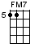

Kokomo Beach Boys
CHORUS
[C]Aruba, Jamaica, ooh I want to take ya.
Ber[F]muda, Bahama, come on pretty mama.
Key [C]Largo, Montego, baby why don't we go,

Ja[F↓]maica..Off the Florida [C]Keys, [Cmaj7]
[Gm7] there's a place called [F]Kokomo.
[Fm] That's where you [C]want to go
to get a[D7]way from it all. [G7]

[C] Bodies in the [Cmaj7]sand,
[Gm7]Tropical drink melting [F]in your hand.
[Fm] We'll be falling in [C]love,
To the rhythm of a [D7]steel drum band, [G7↓]down in Kokomo,

CHORUS
A[C]ruba, Jamaica, ooh I want to take ya,
To Ber[F]muda, Bahama, come on pretty mama.
Key [C]Largo, Montego, baby why don't we go down to
[F]Kokomo. We'll [Fm]get there fast and then we'll [C]take it slow.
[Am]That's where we [Dm]want to go, [G7↓] way down in Koko[C]mo.

Martinique that Montserrat mystique...

[C↓] We'll put out to [Cmaj7]sea,
[Gm7] and we'll perfect our [F]chemistry.
[Fm] By and by we'll de[C]fy a little bit of [D7]gravity. [G7]

[C] Afternoon de[Cmaj7]light,
[Gm7] cocktails and [F]moonlit nights.
[Fm] That dreamy look in your [C]eye,
Give me a tropical [D7]contact high,
[G7↓]way down in Kokomo.

REPEAT CHORUS
Port au Prince, I wanna catch a glimpse…

[C↓] Everybody [Cmaj7]knows,
[Gm7] a little place like [F]Kokomo.
[Fm] Now if you [C]wanna go and get a[D7]way from it all
[G7↓] Go down to Kokomo.

REPEAT CHORUS
REPEAT CHORUS
[C↓] [C↓↓↓]

Maggie May Rod Stewart
[A]Wake up Maggie I [G]think I've got something to [D]say to you  It's [A]late September and I [G]really should be [D]back at school  I [G]know I keep you [D]amused,  But I [G]feel I'm being [A]used  Oh Mag[Em]gie I couldn`t have [F#m]tried any [Em]more [Asus4]  You [Em]lured me away from [A]home  just to [Em]save you from being a[A]lone  You [Em]stole my heart, and [A]that's what really [D]hurts  The mor[A]ning sun when it's [G]in your face really [D]shows your age  But [A]that don't worry me [G]none, in my eyes you're [D]everything  I [G]laughed at all your [D]jokes,  my [G]love you didn't need to [A]coax  Oh Mag[Em]gie I couldn`t have [F#m]tried any [Em]more [Asus4]  You [Em]lured me away from [A]home  just to [Em]save you from being a [A]lone  You [Em]stole my soul that's a [A]pain I can do with[D]out  [A]All I needed was a [G] friend to lend a [D] guiding hand  But you [A]turned into a lover  and [G] mother what a lover you [D] wore me out  All you did [G] was wreck my [D] bed  And in the [G] morning kick me in the [A] head  Oh Ma [Em] ggie I couldn’t have [F#m] tried any [Em] more [Asus4]  You [Em]lured me away from [A]home  'cause you [Em]didn't want to be a[A]lone  You [Em]stole my heart I couldn't [A]leave you if I [D]tried  [A]I suppose I should col[G]lect my books and get [D]back to school  Or [A]steal my daddy's [G]cue make a living out of [D]playing pool  Or [G]find myself a rock and roll [D]band  that [G]needs a helping [A]hand  Oh Mag[Em]gie, I wish I'd [F#m]never seen your [Em]face [Asus4]  You made a first class fool out of [A]me,  but I'm as [Em]blind as a fool can [A]be  You [Em]stole my heart but I [A]love you any [D]way | 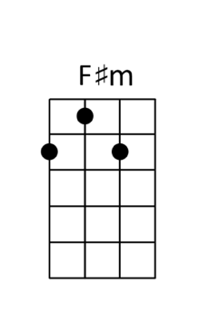

Mamma Mia ABBA
[C] [Caug] [C] [Caug]  [C] I've been [G] cheated by [C] you since I [G] don't know [F] when  [C] So I [G] made up my [C] mind, it must [G] come to an [F] end  [C] Look at me now, [Caug] will I ever learn?  [C] I don't know how [Caug] but I suddenly  [F] lose control. There's a fire with [G7] in my soul  [F] Just [C] one [G] look and I can hear a bell ring  [F] One [C] more [G] look and I forget everything, o-o-o-oh  [C] Mamma mia, here I go again  [Bb] my [F] my, how can I re[C]sist you?  [C] Mamma mia, does it show again?  [Bb] My [F] my, just how much I've [C] missed you  Yes, I've been [G] brokenhearted [Am] blue since the [Em] day we parted  [Bb] Why, [F] why [Dm] did I ever [G7] let you go?  [C] Mamma mia, [Am] now I really know,  [Bb] My [F] my, [Dm] I could never [G7] let you go.  [C] [Caug] [C] [Caug]  [C] I've been [G] angry and [C] sad about the [G] things that you [F] do  [C] I can't [G] count all the [C] times that I've [G] told you we're [F] through  [C] And when you go, [Caug] when you slam the door.  [C] I think you know [Caug] that you won't be  a [F] way too long You know that I'm [G7] not that strong.  [F] Just [C] one [G] look and I can hear a bell ring  [F] One [C] more [G] look and I forget everything, o‐o‐o‐oh  [C] Mamma mia, here I go again  [Bb] my [F] my, how can I re[C]sist you?  [C] Mamma mia, does it show again?  [Bb] My [F] my, just how much I've [C] missed you  Yes, I've been [G] brokenhearted [Am] blue since the [Em] day we parted  [Bb] Why, [F] why [Dm] did I ever [G] let you go?  [C] Mamma mia, [Am] even if I say [Bb] Bye [F] bye, [Dm] leave me now or [G] never  [C] Mamma mia, [Am] it's a game we play  [Bb] Bye [F] bye [Dm] doesn't mean for [G] ever  [C] Mamma mia, here I go again [Bb] my [F] my, how can I re[C]sist you?  [C] Mamma mia, does it show again?  [Bb] My [F] my, just how much I've [C] missed you  Yes, I've been [G] brokenhearted [Am] blue since the [Em] day we parted [Bb] Why, [F] why [Dm] did I ever [G7] let you go?  [C] Mamma mia, [Am] now I really know,  [Bb] My [F] my, [Dm] I could never [G7] let you go.  [C] [Caug] [C] [Caug] [C] | 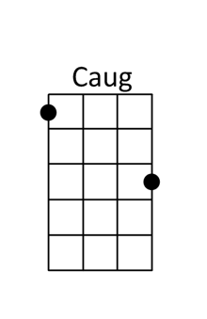

Man Of Constant Sorrow Soggy Bottom Boys
[F] [F7] [Bb] [C7] [F]  [F] I am the man [F7] of constant [Bb] sorrow  I've seen [C7] trouble on my [F] days  [F] I bid farewell [F7] to old [Bb] Kentucky  The place where [C7] I was born and [F] raised  The place where [C7] he was born and [F] raised  [F] [F7] [Bb] [C7] [F]  [F] For six long years [F7] I've been in [Bb] trouble  No pleasure [C7] here on earth I [F] find  [F] For in this world [F7] I'm bound to [Bb] ramble  I have no [C7] friends to help me [F] now  He has no [C7] friends to help him [F] now  [F] [F7] [Bb] [C7] [F]  [F] It's fare thee [F7] well, my old true [Bb] lover  I never ex[C7]pect to see you a[F]gain  [F] For I'm bound to ride [F7] that northern [Bb] railroad  Perhaps I'll [C7] die upon this [F] train  Perhaps he’ll [C7] die upon this [F] train  [F] [F7] [Bb] [C7] [F]  [F] Maybe your friends think [F7] I'm just a [Bb] stranger  My face you'll [C7] never see no [F] more  [F] But there is one promise [F7] that is [Bb] given  I'll meet you [C7] on God's golden [F] shore  He’ll meet you [C7] on God's golden [F] shore  [F↓] [C7↓] [F↓] | 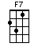

Margaritaville Jimmy Buffet
INTRO  C F G C  A|-------------------------------------------------------------|  E|--3--3--3--1--3----3--3--3--1--3-----5--5--5--3--1--0--------|  C|--4--4--4--2--4----4--4--4--2--4-----5--5--5--4--2--0--------|  G|-------------------------------------------------------------|  C C C4 C C C4 C  Nibblin' on sponge cake. Watchin' the sun bake  C C C4 C G G4 G G2  All of those tourists covered with oil.  G G G2 G G G2 G  Strummin' my four-string. On my front porch swing  G G G4 C C7  Smell those shrimp, they're beginnin' to boil  CHORUS  F G G2 C C7  Wastin away again in margaritaville  F G G2 C C7  Searching for my lost shaker of salt  F G G2 C↓ G↓ F↓  Some people claim that there's a wo-man to blame  G G G2 G C C4 C C C4 C  But I know it's nobodys fault  C C C4 C C C4 C  Don't know the reason, I stayed here all season  C C C4 C G G4 G G2  Nothin to show but this brand new tattoo  G G G2 G G G2 G  But it's a real beauty, A mexican cutie  G G G4 C C7  How it got here I haven't a clue  REPEAT CHORUS  G G G2 G C C4 C C C4 C  Now I think, hell, it could be my fault  C C C4 C C C4 C  I blew out my flip-flop. Stepped on a pop-top  C C C4 C G G4 G G2  Cut my heel had to cruise on back home  G G G2 G G G2 G  But there's booze in the blender. And soon it will render  G G G4 C C7  That frozen concoction that helps me hang on  REPEAT CHORUS  G G G2 G C C4 C C C4 C  But I know it's my own damn fault. Yes and…  F G G2 C↓ G↓ F↓  some people claim that there's a woman to blame  G G G2 G C C4 C  And I know it's my own damn fault  REPEAT INTRO | 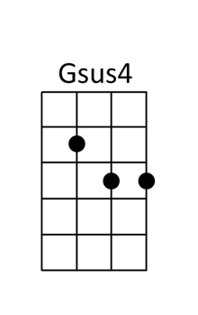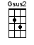

Marry You Bruno Mars
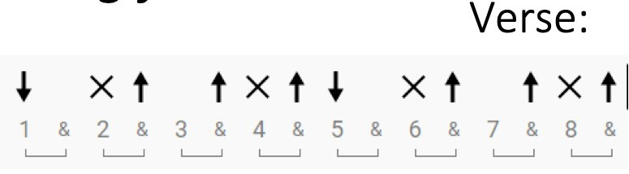
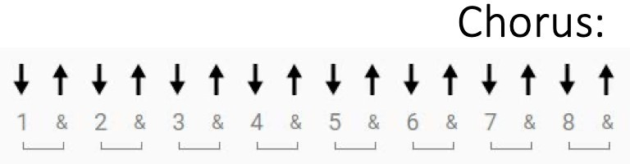
CHORUS
[A] It’s a beautiful night, we’re looking for something [Bm] dumb to do
Hey [D] baby I think I wanna marry you [A]
[A] Is it the look in your eyes? or is it this [Bm] dancing juice?
Who [D] cares baby I think I wanna marry you [A]

[A] Well I know this little chapel on the boulevard we can [Bm] go
No one will [D] know oh come [A] on girl
[A] Who cares if we’re trashed got a pocket full of cash We can [Bm] blow shots of [D]patron and it’s [A] on girl

[A] Don’t say no no no no no just say [Bm] Yeah yeah yeah yeah yeah
And we’ll [D] go go go go go if you’re [A] ready like I’m ready

REPEAT CHORUS

[A] I’ll go get a ring let the choir bells sing like [Bm] oooh
So wotcha wanna [D] do let’s just [A] run girl
[A] If we wake up and you wanna break up that’s [Bm] cool
No I won’t blame [D] you it was [A] fun girl

[A] Don’t say no no no no no just say [Bm] Yeah yeah yeah yeah yeah
And we’ll [D] go go go go go if you’re [A] ready like I’m ready

REPEAT CHORUS

[A] Just say I do-ooo- [Bm]oooo tell me right [D] now baby
Tell me right [A] now baby baby just say I do-ooo- [Bm]oooo
Tell me right [D] now baby tell me right [A] now baby baby oh

[A↓] It’s a beautiful night
We’re looking for something [Bm↓] dumb to do
Hey [D↓] baby I think I wanna marry you [A↓]

No Diggity Blackstreet
[Gm] [Cm7] [Gm]Mmm hmm x3  [Eb] [D7] Shorty  [Gm]get down, [Cm7]good Lord.  [Eb]Baby got 'em open all [D]over town  [Gm]Strickly biz she don't [Cm7]play around  Cover [Eb]much grounds. Got [D]game by the pound  [Gm]Gettin paid is her [Cm7]forte  Each and [Eb]every day true [D]player way  [Gm]I can't get her outta my [Cm7]mind  [Eb]I think about the girl all the [D]time  [Gm]East side to the [Cm7]west side  Push your [Eb]fat rides it's [D]no surprise  [Gm]She got tricks in the [Cm7]stash  Stacking up the [Eb]cash. Fast when it [D]comes to the gas  [Gm]By no means [Cm7]average  She's [Eb]on when she's got to [D]have it  [Gm]Baby you're a perfect [Cm7]10, I wanna get  [Eb]in. Can I [D]get down so I can win  CHORUS  [Gm]I like the way you [Cm7]work it.  No [Eb]Diggity, I gotta [D]bag it up x4  [Gm]She's got [Cm7]class and style  [Eb]Street knowledge, [D]by the pound  [Gm]Baby [Cm7]never act wild,  [Eb]very low key on the [D]profile  [Gm]Catching feelings is [Cm7]a no  [Eb]Let me tell you how[D]it goes  [Gm↓]Curve’s the word. [Cm7] ↓Spin’s the verb.  [Eb↓]Lovers [Eb↓]it [Eb↓]curves [Eb↓]so [D]freak what you heard  [Gm]Rollin with [Cm7]the fatness  [Eb]You don't even know [D]what the half is  [Gm]You gotta pay to play[Cm7]  [Eb]Just for shorty bang [D]bang to look your way, so  [Gm]I like the way you [Cm7]work it  Trump [Eb]tight all day, [D]everyday  You're [Gm↓] blowing my mind, [Cm↓]maybe in time  [Eb↓]Baby [Eb↓]I can [Eb↓]get [Eb↓]you [D]in my ride  REPEAT CHORUS  [Gm]Hey yo hey [Cm7]yo hey yo hey [Eb]yo[D] x4  [Gm] [Cm7] [Gm]Mmm hmm x3 | 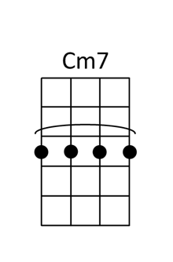

Nonsense Sabrina Carpenter
[Dmaj7] [C#7] [F#m] [A] x2  Think I only [Dma7]want one number in my [C#7]phone  I might change your [F#m]contact to “Donʼt leave me a[A]lone”  You said you like my [Dma7]eyes and you like to make ʼem [C#7]roll  Treat me like a [F#m]queen, now you got me feelinʼ [A]throned, oh  PRE-CHORUS  But I canʼt [Dma7]help myself when you get [C#7]close to me  Baby, my [F#m]tongue goes numb, sounds like “[A]blee-blah-blee”  I donʼt want [Dma7]no one else (No, no), baby, Iʼm [C#7]in too deep  Hereʼs a little [F#m]song I wrote (A song I wrote)  Itʼs about [A]you and me (Me)  CHORUS  Iʼll be [Dmaj7] honest  [C#7]Lookinʼ at you got me thinkinʼ [F#m] n onsense  [A]Cartwheels in my stomach when you [Dma7]walk in  And [C#7]when you got your arms around me  [F#m]Oh, it feels so [A] g ood  I had to jump the [Dma7]octave  I [C#7]think I got an ex, but I for[F#m]got him  And [A]I canʼt find my chill, I mustʼve [Dma7]lost it  [C#7]I donʼt even know, Iʼm talkinʼ [F#m]nonsense  Iʼm talkinʼ[A], Iʼm talkinʼ (Ah-ah-ah), Iʼm talkinʼ  Iʼm talkinʼ [Dma7]all around the clock  Iʼm talkinʼ [C#7]hope nobody knocks  Iʼm talkinʼ [F#m]opposite of soft  Iʼm talkinʼ [A]wild, wild thoughts  You gotta [Dma7]keep up with me  I got some [C#7]young energy  I caught the [F#m]L-O-V-E  How do you [A]do this to me?  REPEAT PRE-CHORUS  REPEAT CHORUS  [Dma7] [C#7]This song catchier than chicken [F#m] pox is  I [A]bet your house is where my other [Dma7]sock is  Woke [C#7]up this morning thought Iʼd write a [F#m]pop hit  How [A]quickly can you take your clothes off? [Dma7]Pop quiz  [C#7][F#m][A][Dma7][C#7][F#m↓] | 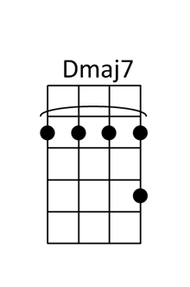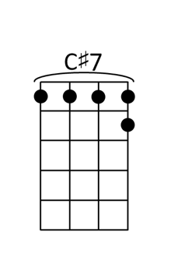

Octopus’s Garden Beatles
[C] [Am] [F] [G7]

[C] I'd like to be…[Am] under the sea,
In an [F]octopus's garden, in the [G7]shade;
[C] He'd let us in…[Am] knows where we've been,
In his [F]octopus's garden, in the [G7]shade.

[Am] I'd ask my friends, to come and see…
[F] An octopus's [G7]garden with me.

[C] I'd like to be…[Am] under the sea,
In an [F]octopus's [G7]garden, in the [C]shade.

[C] We would be warm…[Am] below the storm,
In our [F]little hideaway, beneath the [G7]waves;
[C] Resting our head…[Am] on the sea bed,
In an [F]octopus's garden, near a [G7]cave.

[Am] We would sing…and dance around,

[F] Because we know, we [G7]can't be found.

[C] I'd like to be…[Am] under the sea,
In an [F]octopus's [G7]garden, in the [C]shade.

[C] We would shout…[Am] and swim about,
The [F]coral that lies, beneath the [G7]waves;
(Lies beneath the ocean waves)
[C] Oh what joy, for [Am]every girl and boy,
[F]Knowing they're happy and they're [G7]safe.
(Happy and they're safe)

[Am] We would be…so happy you and me,
[F]No one there, to tell us what to [G7]do.

[C] I'd like to be…[Am] under the sea,
In an [F]octopus's [G7]garden, with [Am]you…
In an [F]octopus's [G7]garden, with [Am]you…
In an [F]octopus's [G7]garden, with [C]you. [C↓] [G7↓] [C↓]

The One That Got Away Katy Perry
[F]Summer after high school when we first met
We’d [Am]make out in your Mustang to Radiohead
And [Dm]on my eighteenth Birthday
We got matching tatt[A#]oos
Used to [F]steal your parents' liquor And climb to the roof
[Am]Talk about our future Like we had a clue
[Dm]Never planned that one day I'd be losing you[A#]

In another [F]life, I would be your [Am]girl
We'd keep all our pro[Dm]mises, be us against the [A#]world
In another [F]life, I would make you [Am]stay
So I don't have to [Dm]say you were the one that got a[A#]way
The one that got away[F] [F]

[F]I was June and you were my Johnny Cash
Never [Am]one without the other, we made a pact [Dm]
Sometimes when I miss you, I put those records [A#]on
[F]Someone said you had your tattoo removed
[Am]Saw you downtown singing the Blues
It's [Dm]time to face the music. I'm no longer your [A#]muse

But in another [F]life, I would be your [Am]girl
We'd keep all our pro[Dm]mises, be us against the [A#]world
In another [F]life, I would make you [Am]stay
So I don't have to [Dm]say you were the one that got a[A#]way
The one that got away[F]

[F]The one [Am]The one [Dm]The one
[A#]The one that got away

[C] All this money can't buy me a [Dm]time mach[Gm]ine, No[C]
Can't replace you with a [Dm]million [Gm]rings, No[C]
I should've told you what you [Dm]meant to [Gm]me, Whoa[C]
'Cause now I pay the price

In another [F]life, I would be your [Am]girl
We'd keep all our pro[Dm]mises, be us against the [A#]world
In another [F]life, I would make you [Am]stay
So I don't have to [Dm]say you were the one that got a[A#]way
The one that got away[F]

[F]The one [Am]The one [Dm]The one

In another [F]life
I would make you [Am]stay So I don't have to [Dm]say
You were the one that got a[A#]way. The one that got away[F↓]

A Pirate Looks at 40 Jimmy Buffet
G G … G2 G G … G2
Mother, mother ocean, I have heard you call
C CM7 C CM7 C CM7 G …
Wanted to sail upon your waters since I was three feet tall
G2 Am7 Bm7.Am7 G … G4 G … G4
You've seen it all. You've seen it all
G G … G2 G G … G2
Watched the men who rode you, switch from sails to steam
C CM7 C CM7 C CM7 G …
And in your belly you hold the treasure few have ever seen
G2 Am7 Bm7.Am7 G … G4 G … G4
Most of them dreams, most of them dreams
G G … G2 G G … G2
Yes I am a pirate, two hundred years too late
C CM7 C CM7
The cannons don't thunder there's nothin' to plunder,
C CM7 G …
I'm an over forty victim of fate
G2 Am7 Bm7.Am7 G … G4 G … G4
Arriving too late, arriving too late

Chorus
G G2
I have been drunk now for over two weeks
G G2
I passed out and I rallied and I sprung a few leaks, but
C CM7 C CM7
I've got to stop wishin', I got to go fishin'
C CM7 G … G2
Down to rock bottom a-gain, with just a few
Am7 Bm7.Am7 G … G4 G … G4
friends, just a few friends

G G … G2 G G … G2
I've done a bit of smugglin' and I've run my share of grass
C CM7 C CM7 C CM7 G …
I made enough money to buy Miami but I pissed it away so fast
G2 Am7 … Bm7.Am7 G … G4 G … G4
Never meant to last, never meant to last
G↓ G2↓ G↓ G2↓
Mother, mother ocean, after all these years I've found
C CM7 C CM7 C CM7 G …
My occupational hazard being, my occupation’s just not around
G2 Am7 Bm7.Am7 G … G2
I feel like I've drowned, gonna head uptown x2

Repeat Chorus
G↓

Put Your Records On Corrine Bailey Rae
[D][Bm6][Gmaj7][Em6][D]  [D]Three little birds [Bm6]sat on my window  [Gmaj7]And they told me I [Em6]don't need to worry[D]  [D]Summer came like cinnamon[Bm6], so sweet  [Gmaj7]Little girls double-[Em6]dutch on the concret[D]e  [Bm]Maybe [F#]sometimes  We've [Bm7]got it wrong, but it's [E7]alright  The [Gmaj7]more things seem to change  The [Gm6]more they stay the same  Ooh, don't you hesitate  CHORUS  [D]Girl, put your records on  [Bm6]Tell me your favorite song  [Gmaj7]You go [Em6]ahead, let your [D]hair down  [D]Sapphire and faded jeans  [Bm6]I hope you get your dreams  [Gmaj7]Just go [Em6]ahead, let your [D]hair down  POST-CHORUS  [Gmaj7]You're gonna find yourself [Gm6]somewhere, some[D]how  [D]Blue as the sky, [Bm6]sunburnt and lonely  [Gmaj7]Sipping tea in a [Em6]bar by the roadsid[D]e  [D]Don't you let those other [A#maj7]boys fool you  [Gmaj7]Got to love that [Em6]afro hairdo[D]  [Bm]Maybe[F#]sometimes  We [Bm7]feel afraid, but it's[E7]alright  The [Gmaj7]more you stay the same  The [Gm6]more they seem to change  Don't you think it's strange?  REPEAT CHORUS  REPEAT POST-CHORUS  [Em7]'Twas more than I could take. [Em7]Pity for pity's sake  [Bm]Some nights kept me awake. [Bm]I thought that I was stronger  [Em7]When you gonna realize. [Em7]That you don't even have to  [Gmaj7]try any [Em7]longer? [G]Do what you want to  REPEAT CHORUS x2  Ooh, you're gonna find yourself [Gm6↓]somewhere, some[D↓]how | 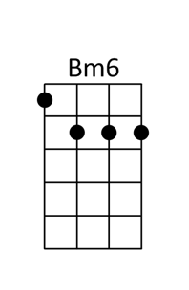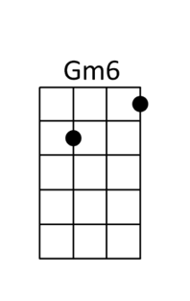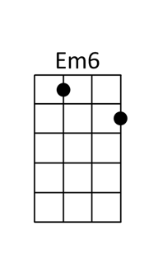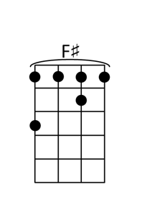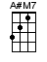

Radioactive Imagine Dragons
[Am] O-[C]oh oh-[G]oh [D]  [Am] O-[C]oh oh-[G]oh [D]  [Am] O-[C]oh oh-[G]oh [G]  [D] oh… 2 | 1 2 | 1 2 | 1 2 |  [Am] I'm waking [C] up to ash and [G] dust  I wipe my [D] brow and I sweat my [Am] rust  I'm breathing [C] in the chemicals [G↓] <inhale> <exhale>  [Am] I'm breaking [C] in, shaping [G] up  Then checking [D] out on the prison bus [Am]  This is [C] it the apoca-[G]lypse, whoa-o-[D]oh  CHORUS  I’m waking [Am] up, I feel it [C] in my bones  E-[G]nough to make my [D] systems grow  [Am] Welcome to the new age [C] to the new age  [G] Welcome to the new age [D] to the new age  [Am] Whoa-o-o-oh-oh [C] whoa-o-o-oh I'm  [G] radioactive [D] radioactive [Am]  Whoa-o-o-oh-oh [C] whoa-o-o-oh I'm  [G] radioactive [D↓] radioactive  [Am] I raise my [C] flags, don my [G] clothes  It's a revo-[D]lution, I sup-[Am]pose  We're painted [C] red, to fit right [G] in,  whoa-[D]oh (whoa-oh)  [Am] I'm breaking [C] in, shaping [G] up  Then checking [D] out on the prison bus [Am]  This is [C] it the apoca-[G]lypse, whoa-[D]oh  REPEAT CHORUS  [Am↓] All systems [G↓] go  [G6↓] sun hasn't [D↓] died  [Am↓] Deep in my [G↓] bones  [G6↓] straight from in-[D↓]side  REPEAT CHORUS  [Am↓] | 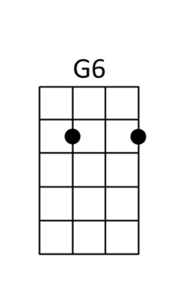

Ripple Grateful Dead
[G] If my words did glow with the gold of [C] sunshine
[C] And my tunes were played on the harp un-[G]strung
[G] Would you hear my voice come through the [C] music
[C] Would you [G] hold it [D] near [C] as it were your [G] own?

[G] If my words did glow with the gold of [C] sunshine
[C] And my tunes were played on the harp un-[G]strung
[G] Would you hear my voice come through the [C] music
[C] Would you [G] hold it [D] near [C] as it were your [G] own?

[G] It's a hand-me-down, the thoughts are [C] broken
[C] Perhaps they're better left un-[G]sung
[G] I don't know, don't really [C] care
[G] Let there be [D] songs [C] to fill the [G] air [G]

[Am] Ripple in still [D] water
When there [G] is no pebble [C] tossed
Nor [A7] wind to [D] blow

Reach out your [G] hand if your cup be [C] empty
[C] If your cup is full may it be a-[G]gain
[G] Let it be known there is a [C] fountain
[G] That was not [D] made [C] by the hands of [G] men

[G] There is a road, no simple [C] highway
[C] Between the dawn and the dark of [G] night
[G] And if you go no one may [C] follow
[G] That path is [D] for [C] your steps [G] alone [G]

[Am] Ripple in still [D] water
When there [G] is no pebble [C] tossed
Nor [A7] wind to [D] blow

You who [G] choose to lead must [C] follow
[C] But if you fall you fall a-[G]lone
[G] If you should stand then who's to [C] guide you?
[G] If I knew the [D] way [C] I would take you [G] home

Lat da dat [G] da, Lah da-ah da [C] da, da
[C] La da da, la da, da da da-ah, da [G] da
[G] Lat da dat da, Lah da-ah da [C] da, da
[G] La da da [D] da, [C] Lah da da da [G↓] da

The Rock Show Blink 182
[F] [F] [Bb] [C] [F] [F] [Bb] [C] [F]

[F]Hanging out behind the club at the weekends
[Bb]Acting stupid getting [C]drunk with my best friends
[F]I couldn´t wait for the summer and the Warped Tour
[Bb] I remember it´s the [C]first time I saw her there

[F] [F] [Bb] [C] [F] [F] [Bb] [C]

[F]She´s getting kicked out of school because she´s failing
[Bb]I´m kind of nervous cause I [C]think all her friends hate me
[F]She´s the one she´ll always be there
[Bb]She took my hand and that [C]made it I swear

CHORUS
Because I [F]fell in love with the [Dm]girl at the [Bb]rock show
[F]She said "What" and I [Dm]told her that I [Bb]didn´t know
[F]She´s so cool I´m gonna [Dm]sneak in through her[Bb]window
[C]Everything´s better when [Bb]she´s around
I [C]can´t wait til her parents go [Bb]out of town
I [C]fell in love with the [Bb]girl at the [Am]rock show

[F] [F] [Bb] [C] [F] [F] [Bb] [C]

[F]When we said were gonna move to Vegas
[Bb] I remember the [C]ook her mother gave us
[F]Seventeen without a purpose or direction
[Bb]We don´t owe anyone a [C]fucking explanation

REPEAT CHORUS

[F] [F] [Bb] [C] [F] [F] [Bb] [C]

BRIDGE
[Dm]Black and white picture of her [Bb]on my wall
I waited [F]for her call She always [C]kept me waiting
[Dm]And if I ever got a[Bb]nother chance
I´d still ask [F]her to dance Because she [C]kept me [Bb]waiting

REPEAT CHORUS

<Repeat and fade out> [F] I´ll never[Bb] forg[C]et to[F]night

Royals Walk Off The Earth
Riff 1 Riff 2
A|-----3----------| A|-3--------------|
E|---0------------| E|---0------------|
C|-0--------------| C|-----0----------|
G|----------------| G|----------------|

I've never seen a [Riff 1]diamond in the flesh [Riff 1]
I cut my [Riff 1]teeth on wedding rings in the [Riff 1]movies
And I'm not [Riff 1]proud of my address, [Riff 1]
In a torn up [Riff 1]town, No post code envy [Riff 1]

PRE-CHORUS
But every song is like [C]gold teeth, grey goose, trippin' in the bathroom
Blood stains, ball gowns, trashin' the hotel room,
[Bb]We don't care, we're driving [F]Cadillacs in our dreams
But everybody's like [C]crystal, Maybach, diamonds on your timepiece
Jet planes, islands, tigers on a gold leash
[Bb]We don't care, we aren't [F]caught up in your love affair

CHORUS
And we'll never be [C]royals...
It don't run in our blood
That kind of [Bb]luxe just ain't for us
We crave a [F]different kind of buzz
Let me be your [C]ruler...
You can call me queen bee
And baby i'll [Bb]rule (I'll rule) (I'll rule) (I’ll ruu-uule)...
[F]Let me live that fantasy [Riff 1] [Riff 2]

My friends and [Riff 1]I we've cracked the code. [Riff 2]
We count our [Riff 1]dollars on the train to the [Riff 2]party
And every[Riff 1]one who knows us kno-o-[Riff 2]o-ws
that we 're fine with [Riff 1]this. We didn't come from [Riff 2]money

REPEAT PRE-CHORUS
REPEAT CHORUS

[C↓]Oooh oooooh [C↓] oooooh ohhh
[Bb↓]We're bigger than we every dreamed,
and I'm in [F↓]love with being queen
[C↓]Oooh oooooh [C↓] oooooh ohhh
[Bb]Life is game without care,
we aren't [F]caught up in your love affair

REPEAT CHORUS [F↓]

Runaround Blues Traveler

[E] [A] [F#m] [B]

[E]Once u[A]pon a [F#m]midnight [B]dearie
I [E]woke with something [A]in my [F#m]head [B]
I [E]couldn't es[A]cape the [F#m]memor[B]y of a
[E]phone call and of [A]what you said[F#m] [B]

Like a [E]game show con[A]testant with a [F#m]parting [B]gift
I could [E]not be[A]lieve my [F#m]eyes [B]
When I [E]saw through the [A]voice of a [F#m]trusted [B]friend
Who needs to [E]humor me and [A]tell me [F#m]lies [B]
Yeah [E]humor me and [A]tell me [F#m]lies [B]

And [E]I'll lie [A]too and say [F#m]I don't [B]mind
And [E]as we [A]seek so [F#m]shall we [B]find
And [E]when you're feeling [A]open I'll [F#m]still be [B]here
But [E]not without a [A]certain de[F#m]gree of [B]fear
Of [E]what will [A]be with [F#m]you and [B]me
I [E]still can [A]see things [F#m]hopefull[B]y

CHORUS
But [E]you [A] [F#m] [B]Why you wanna
[E]give me the [A]run-a[F#m]round [B]
Is it a [E]sure-fire [A]way to [F#m]speed things [B]up
When [E]all it does [A]is s-[F#m]lo[B]w me
[E]down [A] [F#m] [B]

And [E]shake me [A]and my [F#m]confidence [B]
About a [E]great [A]many things[F#m] [B]
But I've [E]been there [A]I can [F#m]see it [B]cower
Like a [E]nervous magician [A]waiting in the [F#m]wings [B]

Of a [E]bad [A]play where the [F#m]heroes are [B]right
And [E]nobody [A]thinks or [F#m]expects too [B]much
And [E]Hollywood's [A]calling for the [F#m]movie [B]rights
Singing [E]baby let's [A]keep in [F#m]touch [B]
Hey [E]baby let's [A]keep in [F#m]touch [B]

But I want [E]more than a [A]touch I [F#m]want you to reach [B]me
And [E]show me all the [A]things no one [F#m]else can [B]see
So [E]what you [A]feel becomes [F#m]mine as [B]well
And [E]soon if we're [A]lucky we'd be [F#m]unable to [B]tell
What's [E]yours and [A]mine, the [F#m]fishing's [B]fine
And it [E]doesn't have to [A]rhyme, so don't you [F#m]feed me a [B]line

REPEAT CHORUS

Tra la la la la [E]bombar[A]dier this [F#m]is the pilot [B]speaking
And I've [E]got some [A]news for [F#m]you [B]
It seems my [E]ship still [A]stands no matter [F#m]what you [B]drop
And there ain't a [E]whole lot that [A]you can [F#m]do [B]

Oh sure the [E]banner may be [A]torn and the [F#m]wind's gotten [B]colder
[E]Perhaps I've [A]grown a little [F#m]cynical [B]
But I know [E]no matter [A]what the [F#m]waitress [B]brings
I shall [E]drink it and [A]always be [F#m]full [B]
Yeah, I will [E]drink it and [A]always be [F#m]full [B]

Oh [E]I like [A]coffee, and [F#m]I like [B]tea
I'd like to [E]be able to [A]enter a [F#m]final [B]plea
I [E]still got this [A]dream that you [F#m]just can't [B]shake
I [E]love you to the [A]point you can no [F#m]longer [B]take

Well all [E]right [A]okay So [F#m]be that [B]way
I [E]hope and [A]pray that there's [F#m]something left to [B]say

But [E]you [A] [F#m] [B]Why you wanna
[E]give me the [A]run-a[F#m]round [B]
Is it a [E]sure-fire [A]way to [F#m]speed things [B]up
When [E]all it does [A]is slow me [F#m]down [B]

REPEAT CHORUS
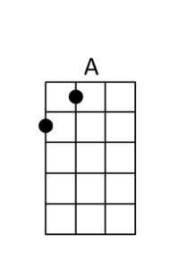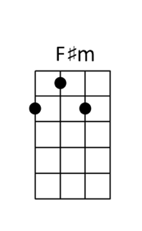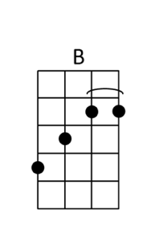

Sad Songs Say So Much Elton John
[C] [F] [G] [C]

Guess there are [C] times when we all need to share a [F] little pain
And ironing out the [G] rough spots
Is the hardest part when [C] memories remain
And it's [C] times like these when we all need to hear the [F] radio
‘Cause from the [G] lips of some old singer
We can share the troubles [C] we already know

CHORUS
Turn them [C] on, turn them on
Turn on those [F] sad songs
When all hope is [G] gone
Why don't you [G] tune in and [F] turn them [C] on
They reach into your [C] room ohh ohhh
Just feel their [F] gentle touch
When all hope is [G] gone
Sad songs [F] say so [C] much

If someone else is [C] suffering enough… ohhh to [F] write it down
When every single [G] word makes sense
Then it's easier to [C] have those songs around
The kick [C] inside is in the line that finally [F] gets to you
and it feels so good to [G] hurt so bad
And suffer just enough to [C] sing the blues

REPEAT CHORUS

Sad songs they [F] say
Sad songs they [G] say
Sad songs they [F] say
Sad songs they [G] say [F] so [G] much

REPEAT CHORUS

When all hope is [G] gone, you know, sad songs [F] say so [C] much
When every little bit of [G] hope is gone,
sad songs [F] say so [C] much
When every little bit of [G] hope is gone,
sad songs [F] say so [C] much
When all hope is [G] gone, you know, sad songs [F] say so [C] much
When every little bit of [G] hope is gone,
sad songs [F] say so [C] much
<fade> When every thing you do is [G] going wrong,
sad songs [F] say so [C↓] much

Santeria Sublime
[F][A][Dm][C]

I don't [F]practice santeria I ain't [A]got no crystal ball
I [Dm]had a million dollars but I'd,[C]I'd spend it all
If [F]I could find that Heina and that [A]Sancho she's found
Well I'd [Dm]pop a cap in Sancho and I'd [C]slap her down

[Bb]All I [C]really wanna [F]know my [Dm]baby
[Bb]All I [C]really wanna [F]say I [Dm]can't de[Bb]fine
It's [C]love that I [F]need [Dm]
[Bb] But my [C]soul will have to

[F]Wait 'till I get back, find a [A]Heina of my own
[Dm]Daddy's gonna [C]love one and all
I [F]feel the break, feel the break, fe[A]el the break
And I [Dm]gotta live it up [C]Oh yeah, uh huh, well I swear that I

[Bb]All I [C]really wanna [F]know my [Dm]baby
[Bb]All I [C]really wanna [F]say I [Dm]can't de[Bb]fine
That [C]love will make it [F]go[Dm]
[Bb] My soul[C]will have to...

I don't [F]practice santeria I ain't [A]got no crystal ball
I [Dm]had a million dollars but I'd,[C]I'd spend it all
If [F]I could find that Heina and that [A]Sancho she's found
Well I'd [Dm]pop a cap in Sancho and I'd [C]slap her down

[Bb]All I [C]really wanna [F]say my [Dm]baby
[Bb]All I [C]really wanna [F]say is [Dm]I've got [Bb]mine
And I'll [C]make it yes [F]I'm comin' up[Dm]
[Bb] Tell Sanch[C]ito that if

[F]He knows what is good for him he [A]best go run and hide
[Dm]Daddy's got a new forty-[C]five
And [F]I won't think twice
to stick that barrel
[A]straight down Sancho's throat
Be[Dm]lieve me when I say that I've [C]got something for his punk ass

[Bb] Well I [C]really wanna [F]know my [Dm]baby
[Bb] What I [C]really wanna [F]say is [Dm]there's j[Bb]ust one
way back[C] And I'll [F]ma-a-[Dm]ake it
[Bb] yeah my [C]soul will have to [F↓]wait

[E↓][Dm↓][C↓][Bb↓][C↓][F7↓]

Satisfaction Rolling Stones
[C] I can't get no[F] satisfaction, [C] I can't get no[F]satisfaction
Cause I [C]try, and I [G7]try, and I [C]try, and I [F]try.
I can't [C]get no, [F] I can't [C]get no[F]

[F] When I'm [C]drivin' in my [F]car,
And that [C]man comes on the r[F]adio
And he's [C]tellin' me more and [F]more,
about some [C]useless infor[F]mation,
Supposed to [C]fire my imagin[F]ation
I can't [C]get no.[F] Oh, no, no, [C↓]no[mute↓↓↓↓↓]
[mute↓]Hey, hey, [mute↓]hey [C] [F]. that' what I say. [C] [F]

[C] I can't get no[F] satisfaction, [C] I can't get no[F]satisfaction
Cause I [C]try, and I [G7]try, and I [C]try, and I [F]try.
I can't [C]get no, [F] I can't [C]get no[F]

When I'm [C]watchin' my T-[F]V,
And that [C]man comes on to [F]tell me
How [C]white my shirts can [F]be,
Well, he [C]can't be a man 'cause [F]he
doesn't smoke the [C]same cigarettes as [F]me.
I can't [C]get no.[F] Oh, no, no, [C↓]no[mute↓↓↓↓↓]
[mute↓]Hey, hey, [mute↓]hey [C] [F]. that' what I say. [C] [F]

[C] I can't get no[F] satisfaction, [C] I can't get no [F]girl reaction
Cause I [C]try, and I [G7]try, and I [C]try, and I [F]try.
I can't [C]get no, [F] I can't [C]get no[F]

When I'm [C]ridin' 'round the [F]world,
And I'm [C]doin' this and I'm [F]signin' that
And I'm [C]tryin' to make some girl [F]
Who tells me, [C]baby, better come back [F]later
next week, 'cos you [C]see I'm on a [F]losing streak
I can't [C]get no.[F] Oh, no, no, [C↓]no[mute↓↓↓↓↓]
[mute↓]Hey, hey, [mute↓]hey [C] [F]. that' what I say. [C] [F]

I can't [C]get no, [F] I can't [C]get no[F]
[F] I can't [C]get no [F] satisf[C]action[F]
no satis[C]faction,[F]
no satis[C]faction,[F]
no satis[C]faction[F]

Sittin’ On the Dock Of the Bay Otis Redding
[G]Sittin' in the mornin' [B]sun  I'll be [C]sittin' when the [C↓]ev-[B↓]en-[Bb↓]in' [A]comes  [G]Watching the ships roll [B]in  And then I [C]watch 'em roll a[C↓]way[B↓] [Bb↓]a[A]gain, yeah  CHORUS  I'm [G]sittin' on the dock of the [E7]bay  Watching the [G]tide roll a[E7]way  Ooo, I'm just [G]sittin' on the dock of the [A]bay  Wastin' [G]ti-i-i-i-[E7]ime  I [G]left my home in [B]Georgia  [C]Headed for the [C↓]'Fri[B↓]sco[Bb↓] [A]Bay  [G]'Cause I've had nothing to [B]live for  And look like [C]nothin's gonna [C↓]come [B↓]my[Bb↓] [A]way  REPEAT CHORUS  [G]Looks [D]like, [C]nothing's gonna [G]change  [G]Everyt[D]hing still re[C]mains the [G]same  [G]I can't [D]do what [C]ten people [G]tell me to do  [F]So I guess I'll re[D]main the same, yes  [G]Sittin' here resting my [B]bones  And this [C]loneliness won't [C↓]leave [B↓]me [Bb↓]a[A]lone  It's [G]two thousand miles I [B]roamed  Just to [C]make this [C↓]dock [B↓]my[Bb↓] [A]home  REPEAT CHORUS  Now I'm just gonna [G]sit on the dock of the [E7]bay  Watching the [G]tide roll a[E7]way  Ooo, I'm [G]sittin' on the dock of the [A]bay  Wastin' [G]tim[E7]e  (whistle)  [G] [G] [G] [E7] | [G] [G] [G] [E7] | [G↓] | 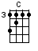

Sloop John B Beach Boys
We [F] come on the sloop [Bb] John [F] B,  My grandfather [Bb] and [F] me,  Around Nassau town we did [C] roam,  Drinking all [F] night, [F7]  Got into a [Bb] fight, [Bbm]  Well, I [F] feel so broke up, [C] I wanna go [F] home  So [F] hoist up the John [Bb] B’s [F] sail,  See how the main [Bb] sail [F] sets,  Call for the Captain ashore and let me go [C] home  Let me go [F] home, [F7] I wanna go [Bb] home, [Bbm] yeah, yeah,  Well, I [F] feel so broke up, [C] I wanna go [F] home  The [F] first mate he [Bb] got [F] drunk,  And broke in the Cap[Bb]tain’s [F] trunk,  The constable had to come and take him a-[C]way,  Sheriff John [F] Stone, [F7]  Why don’t you leave me a-[Bb]lone, [Bbm] yeah, yeah,  Well, I [F] feel so broke up [C] I wanna go [F] home  So [F] hoist up the John [Bb] B’s [F] sail,  See how the main [Bb] sail [F] sets,  Call for the Captain ashore and let me go [C] home  Let me go [F] home, [F7] I wanna go [Bb] home, [Bbm] yeah, yeah,  Well, I [F] feel so broke up, [C] I wanna go [F] home  The poor [F] cook he caught [Bb] the [F] fits,  And threw away all [Bb] my [F] grits,  And then he took and he ate up all of my [C] corn,  Let me go [F] home, [F7]  Why don’t they let me go [Bb] home? [Bbm]  This [F] is the worst trip, [C] I’ve ever been [F] on  So [F] hoist up the John [Bb] B’s [F] sail,  See how the main [Bb] sail [F] sets,  Call for the Captain ashore and let me go [C] home  Let me go [F] home, [F7] I wanna go [Bb] home, [Bbm] yeah, yeah,  Well, I [F] feel so broke up, [C] I wanna go [F] home ! [cha cha cha] | 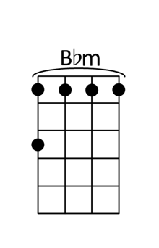

Something Stupid Nancy Sinatra
[G] I know I stand in [Em7] line until you [Gmaj7] think  You have the [G] time to spend an  [Am] evening with [D7] me [Am9] [D7]  And [Am] if we go some [D7] place to dance  I [Am9]know that there's a [D7]chance  You won't be [Gmaj7]leaving with [Em7]me [Gmaj7] [Em7]  And [G]afterwards we [Dm7]drop into  a [G7]quiet little place And have a [Cmaj7]drink or two [Eb]  And [Am]then I go and [D7]spoil it all by [Am9]saying  Something [D7]stupid like I [G]love you  I can [G7]see it in your [Dm7]eyes that you de[G7]spise  The same old lines you heard the [Cmaj7]night before  And [A7]though it's just a [Em7]line to you for [A7]me it's true  And never seemed so [Am9]right be[D7]fore [Am][D+]  [G]I practise every [Em7]day to find some [Gmaj7]clever lines  To [G]say to make the [Am]meaning come [D7]true [Am9][D7]  But [Am]then I think I'll [D7]wait until the [Am9]evening gets [D7]late  And I'm a [Gmaj7]lone with [Em7]you [Gmaj7] [Em7]  The [G]time is right your [Dm7]perfume fills my [G7]head  The stars get red and oh the [Cmaj7]night’s so blue [Eb]  And [Am]then I go and [D7]spoil it all by [Am9]saying  Something [D7]stupid like I [G]love you  [G] I know I stand in [Em7] line until you [Gmaj7] think  You have the [G] time to spend an  [Am] evening with [D7] me [Am9] [D7]  And [Am] if we go some [D7] place to dance  I [Am9]know that there's a [D7]chance  You won't be [Gmaj7]leaving with [Em7]me [Gmaj7] [Em7]  The [G] time is right your [Dm7] perfume fills my [G7] head  The stars get red and oh the [Cmaj7] night’s so blue [Eb]  And [Am] then I go and [D7] spoil it all by [Am9] saying  Something [D7] stupid like I [G] love you[Eb]  I [G] love you[Eb]  I [G] love you[Eb]  I [G] love you[Eb] [G↓] | 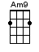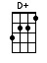

Somewhere Over the Rainbow Israel Kamakawiwo’ole
[C] [Em] | [Am] [F] | [C] [Em] | [Am] [Am7] | [F]
[C] Oooo oooo [Em] oooo oo-o-o [F] Oooo oo-oo [C] Oooo oo-oo
[F] Oooo oooo [E7] oo-o-o [Am] Oo-o-o [F] oo-o-o

[C] Somewhere [Em] over the rainbow [F] way up [C] high
[F] And the [C] dreams that you dream of [G] once in a lulla-
[Am]-by [F] yyy
[C] Somewhere [Em] over the rainbow [F] blue birds [C] fly
[F] And the [C] dreams that you dream of, [G]dreams
really do come [Am] true-oo-oo [F]-oo-oo

Some[C]day I'll wish upon a star,
[G] wake up where the clouds are far be[Am]hind [F] me
Where [C] trouble melts like lemon drops
[G] high above the chimney tops that’s [Am] where you'll [F] find me
[C] Somewhere [Em] over the rainbow [F] bluebirds [C] fly
[F] And the [C] dreams that you dare to, oh [G] why oh why can’t [Am] I-I-I [F] I-I-I well I see

[C] trees of [Em] green and [F] red roses [C] too,
[F] I'll watch then [C] bloom for [E7] me and [Am] you
And I [F] think to myself, [G] what a wonderful [Am] world [F]
Well I see [C] skies of [Em] blue and [F] clouds of [C] white
The [F] brightness of [C] day – [E7] I like the [Am] dark
And I [F] think to myself, [G] what a wonderful [Am] world [F]

The [G] colours of the rainbow so [C] pretty in the sky
Are [G] also on the faces of [C] people passing by
I see [F] friends shaking [C] hands saying, [F] ‘How do you [C] do?’
[F] They're really [C] saying, [F] ‘I, I love [G] you’
I hear [C] babies [Em] cry and I [F] I watch them [C] grow,
[F] They’ll learn [C] much more [E7] than we'll [Am] know
And I [F] think to myself, [G] what a wonderful [Am] world [F] o-orld

Some[C]day I'll wish upon a star,
[G] wake up where the clouds are far be[Am]hind [F] me
Where [C] trouble melts like lemon drops
[G] high above the chimney tops that’s [Am] where [F] you'll find me

[C] Somewhere [Em] over the rainbow [F] way up [C] high
[F] And the [C] dreams that you dare to, [G] why oh why can't [Am] I [F] I-I-I

[C] Oooo oooo [Em] oooo oo-o-o [F] Oooo oo-oo [C] Oooo oo-oo
[F] Oooo oooo [E7] oo-o-o [Am] Oo-o-o [F] oo-o-o [C↓]

Summer Breeze Seals & Croft
Dm C G Dm C G  A|----3-0---------|----------------|----3-0---------|---------------  E|--1-------3---1-|0---------------|--1-------3---1-|0--------------  C|2---------------|--2-0-2---------|2---------------|--2-0-2--------  G|----------------|----------------|----------------|---------------  [D] See the curtains [F]hangin' in the window  [C] In the evenin' on a [G]Friday n[D]ight[F↓][C↓][G↓]  [D] A little light [F]shinin' through the window  [C] Lets me know everyt[G]hing is alr[D]ight[F]  CHORUS  [Gm7] Summer breeze, [Am]makes me feel fine  [Gm7]Blowing through the jasmine in my [F]mind  A|0-1-3-1---0-----|  E|------------1---|  C|----------------|  G|----------------|  [Gm7] Summer breeze, [Am]makes me feel fine  [Gm7]Blowing through the jasmine in my [F]mind  [D] See the paper [F]layin' on the sidewalk  [C] A little music from the [G]house next d[D]oor[F↓][C↓][G↓]  [D] So I walked on [F]up to the doorstep  [C] Through the screen and a[G]cross the fl[D]oor  REPEAT CHORUS  [Dm]Sweet days of [F]summer, the [C]jasmine's in [G]bloom  [Dm]July is [F]dressed up and [C]playing her [G]tune  And I come [Gm7]home from a [Am]hard day's work  And you're [Gm7]waiting there, Not a [Am]care in the [D]world  [D] See the smile [F]waitin' in the kitchen  [C] Food cookin' and the [G]plates there for [D]two[F↓][C↓][G↓]  [D] Feel the arms that [F]reach out to hold me  [C] In the evening when the [G]day is thr[D]ough[F][C][G]  REPEAT CHORUS  Dm C G Dm C G  A|----3-0---------|----------------|----3-0---------|---------------  E|--1-------3---1-|0---------------|--1-------3---1-|0--------------  C|2---------------|--2-0-2---------|2---------------|--2-0-2--------  G|----------------|----------------|----------------|--------------- | 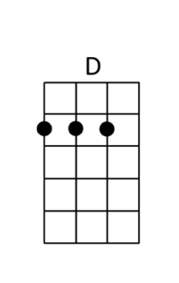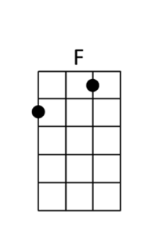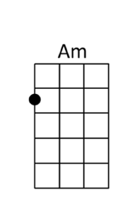

Summer Of ’69 Bryan Adams
[D] [D]

[D] I got my first real four-string
[A] Bought it at the Five and Dime
[D] Played it till my fingers bled
[A] It was the summer of sixty-nine

[D] Me and some guys from school
[A] Had a band and we tried real hard
[D] Jimmy quit… Jodie got married
[A] Shoulda known… we’d never get far

[Bm] Oh, when I [A] look back now
[D] That summer seemed to [G] last forever
[Bm] And if I [A] had the choice
[D] Yeah I’d always [G] wanna be there
[Bm] Those were the [A] best days of my [D] life [A]

[D] Ain’t no use in complainin’
[A] When you’ve got a job to do
[D] Spent my evenin’s down at the drive-in
[A] And that’s when I met you, yeah

CHORUS
[Bm] Standin’ on your [A] mama’s porch
[D] You told me that you’d [G] wait forever
[Bm] Oh and when you [A] held my hand
[D] I knew that it was [G] now or never
[Bm] Those were the [A] best days of my
[D] life… oh [A] yeah… back in the summer of
[D] 69 [A]

[F] Man we were [Bb] killin’ time
We were [C] young and restless… we [Bb] needed to unwind
[F] I guess [Bb] nothin’ can last for[C]ever… forever… no

[D] [A] [D] [A]
[D] And now the times are changin’
[A] Look at everything that’s come and gone
[D] Sometimes when I play that old four-string
[A] I think about ya, wonder what went wrong

REPEAT CHORUS
[D] [A] [D] [A] [D↓]

Summer Wind Wayne Newton
[D] [D6] [Dma7] [D6]  The [D] summer wind [D6] came [Dmaj7] blowin‘ in [D6]  From a[Em7]cross the [A7] sea [Em7] [A7]  It [Em7] lingered [A7] there, so [Em7] warm and [A7] fair  To [D] walk with me [D6]  All [Am7] summer [D7] long, we [Am7] sang a [D7] song  And [Gmaj7] strolled on golden [Gm6] sand  [D6] Two [B7] sweethearts [Em7] and [A7],  the [D] summer wind [A7]  Like [D] painted [D6] kites, those [Dmaj7] days and [D6] nights  Went [Em7] flyin’[A7] by [Em7] [A7]  The [Em7] world was [A7] new,  Be[Em7]neath a [A7] blue um[D]brella sky [D6]  Then [Am7] softer [D7] than, a [Am7] piper [D7] man  one [Gmaj7] day, It called to [Gm6] you  [D6] And I [B7] lost you [Em7] to  [A7] The [D] summer wind [A7]  The [D] autumn [D] wind and the [Dmaj7] winter [D6] wind  Have[Em7] come and [A7] gone [Em7] [A7]  And [Em7] still the [A7] days, those [Em7] lonely [A7] days  Go [D] on and on [D6]  And [Am7] guess who [D7] sighs, his [Am7] lulla[D7]bies  Through [Gmaj7] nights that never [Gm6] end  [D6] My [B7] fickle [Em7] friend, [A7]  The [D] summer wind ….. [A7]  Warm [D] summer wind ….. [A7]  The [D] summer wind [D6↓] | 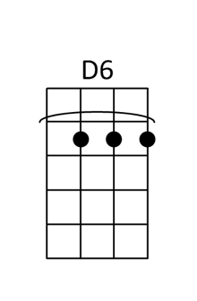
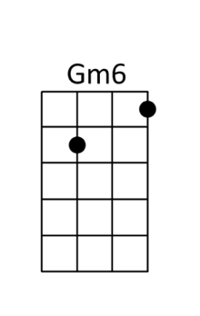

Take It Easy Eagles
[G] [G] [C] [D] [G] [G] [C] [D]
G G
A|1s2---1s2---1s2-0------
E|------------------3-0--
C|----------------------2

Well I'm a-runnin' down the road try'n to loosen my load - I've got
[G]Seven women [D]on my [C]mind
[G]Four that want to own me, [D]two that want to stone me
[C]One says she's a friend of [G]mine

Take it [Em]easy, take it [C]ea[G]sy
Don't let the [Am]sound of your own [C]wheels drive you [Em]crazy
Lighten [C]up while you still [G]can Don't even [C]try to under[G]stand
Just find a [Am]place to make your [C]stand, and take it [G]easy
REPEAT RIFF

Well, I'm a [G]standin' on a corner in Winslow, Arizona
[G]Such a fine [D]sight to [C]see
It's a [G]girl, my Lord, in a [D]flat-bed Ford slowin'
[C]Down to take a look at[G]me

Come on, [Em]bab[D]y, don't say [C]ma[G]ybe
I gotta [Am]know if your sweet [C]love is gonna [Em]save me
We may [C]lose and we may [G]win, though we will
[C]never be here a[G]gain
So open [Am]up I'm climbin' [C]in, so take it [G]easy
G . . . | . . . . | . . D . | C . . . |
G . . . | D . . . | C . . . | G . . . |
Em . . .| D . . . | C . . . | G . . . |
Am . . .| C . . . | Em . . . | . . D
Well, I'm a [G]runnin' down the road tryin' to loosen my load
Got a [G]world of trouble [D]on my [C]mind
[G]Lookin' for a lover who [D]won't blow my cover
She's [C]so hard to [G]find

Take it [Em]easy, take it [C]ea[G]sy
Don't let the [Am]sound of your own [C]wheels make you[Em]crazy
Come on [C]ba[G]by, don't say [C]ma[G]ybe...I gotta
[Am]Know if your sweet [C]love is gonna [G↓]save me

[C]Ooh oh oh - [C]Ooh oh oh - [G]Ooh oh oh - [G]Ooh oh oh
[C]Ooh oh oh - [C]Ooh oh oh - [G]Ea - [Gs4]Ea
[C]sy - [C]We ought to take it – ea - sy
[G]Ea - [Gs4]Ea - [C]sy - [C] [Em↓]

Take Me Home, Country Roads John Denver
[F]

[F]Almost heaven, [Dm]West Virginia,
[C]Blue Ridge Mountains, [A#]Shenandoah [F]River. [F]
Life is old there, [Dm]older than the trees,
[C]Younger than the mountains, [A#]growin' like a [F]breeze.

CHORUS
[F]Country roads, take me [C]home,
To the [Dm]place I be[A#]long:
West [F]Virginia, mountain [C]momma,
Take me [A#]home, country [F]roads.

[F]All my mem'ries, [Dm]gather 'round her,
[C]Miner's lady, [A#]stranger to blue [F]water. [F]
Dark and dusty, [Dm]painted on the sky,
[C]Misty taste of moonshine, [A#]teardrop in my [F]eye.

REPEAT CHORUS

[Dm]I hear her [C]voice, in the [F]mornin' hours she calls me,
The [A#]radio re[F]minds me of my [C]home far away.
And [Dm]drivin' down the [D#]road,
I get a [A#]feelin' that I [F]should have been home [C]yesterday,
yester[C7↓]day.

REPEAT CHORUS
REPEAT CHORUS

Take me [C]home, country [F]roads.
Take me [C]home, down country [F]roads.

Take On Me A-ha
[Am] [D] [G] [C]
[Am] [D] [G] [C]
[Am] [D] [Am] [D]
[Am] We're talking a-[D]way
[G] I don't know what [C] I'm to say
I'll [Am] say it any-[D]way
To-[G]day's another [C] day to find you
[Am] Shying a-[D]way
[Em] I'll be coming for your [C] love, OK?

CHORUS
[G] Take [Bm] on [Em] me, ([C] take on me),
[G] Take [D] me [Em] on, ([C] take on me)
[G] I'll [Bm] be [Em] gone,
[C] In a day or [G] two [D] [Em] [C]

So [Am] needless to [D] say
I'm [G] odds and ends, [C] but… I'll be
[Am] Stumbling a-[D]way
[G] Slowly learning that… [C] life is OK
[Am] Say after [D] me
[Em] It's no better to be [C] safe than sorry

REPEAT CHORUS

[Bm] [F] [Bm] [F] [Am] [D]
[Am] [D] [G] [C] [Am] [D]
[G] [C] [Am] [D] [Am] [D]

Oh, [Am] the things that you say [D]
Yeah, [G] is it live or… [C] just to play
My [Am] worries a-[D]way
You're [G] all the things [C] I've got to remember
You're [Am] shying a[D] way
[Em] I'll be coming for you any-[C]way

REPEAT CHORUS
REPEAT CHORUS
[A↓]

Teenage Dirtbag Wheatus
Her [D]name is Noe[A]lle, [D]I have a drea[G]m about her.
[D]She rings my b[A]ell. I got [D]gym class in ha[G]lf an hour.
[D]Oh, how she r[A]ocks, In [D]keds and tube s[G]ocks,
But [Bm]she doesn't [G]know who I [A]am,
[A]And [Bm]she doesn't [G]give a [A]damn a[A]bout me.

CHORUS
'Cause [D]I'm just a [G]teenage [A]dirtbag,[Bm↓] bab[F#m↓]y.
Yeah [D]I'm just a [G]teenage [A]dirtbag,[Bm↓] bab[F#m↓]y.
[D]Listen to [G]Iron [A]Maiden, [Bm↓]Baby, [F#m↓]with [D]me.
[G]Oo[A]oo…[Bm↓] [F#m↓] [G↓] [A↓]

[D] [A] [D] [G]

Her [D]boyfriends a [A]dick, and [D]he brings a [G]gun to school,
And [D]he'd simply [A]kick, My [D]ass if he [G]knew the truth.
He [D]lives on my [A]block. And he [D]drives an [G]Iroc
But [Bm]he doesn't [G]know who I [A]am,[A]
And [Bm]he doesn't [G]give a [A]damn a[A]bout me.

REPEAT CHORUS

D↓↓xG↑ ↑↓ D↓↓xG↑ ↑↓ D↓↓xG↑ ↑↓
Yeeah, Dirtbag,
No, [Bm↓]She does[F#m↓]n't know [G↓]what she's [A↓]missing.
[D] [G] Yeeah, [D] [G] Dirtbag, [D][G]
No, [Bm↓]She does[F#m↓]n't know [G↓]what she's [A↓]missing.

[D][A][D][G]

Man, [D]I feel like [A]mold, It's [D]prom night and [G]I am lonely.
[D]Lo and be[A]hold: [D]She's walking [G]over to me.
[D]This must be [A]fake, My [D]lip starts to [G]shake.
[Bm]How does she [G]know who I [A]am?[A]
And [Bm]why does she [G]give a [A]damn a[A]bout me?

I've got two [D]tickets to [G]Iron [A]Maiden,[Bm↓] bab[F#m↓]y,
[D]Come with me [G]Friday, [A]don't say [Bm↓]mayb[F#m↓]e.
[D]I'm just a [G]teenage [A]dirtbag [Bm↓]baby [F#m↓]like [D]you.
[G]Oo[A]oo…[Bm↓] [F#m↓] [G↓] [A↓]

D↓↓xG↑ ↑↓ D↓↓xG↑ ↑↓ D↓↓xG↑ ↑↓
Yeeah, Dirtbag,
No, [Bm↓]She does[F#m↓]n't know [G↓]what she's [A↓]missing.
[D] [G] Yeeah, [D] [G] Dirtbag, [D][G]
No, [Bm↓]She does[F#m↓]n't know [G↓]what she's [D]mis – [A]sing.
[D] [G][D][A][D↓↓↓][G↓][F#m↓][Em↓][D]

Tiny Bubbles Don Ho
[D7] [G7] [C] [A7] [D7] [G7] [C]

Tiny [C]Bubbles... in the [G7]wine
Makes me happy, makes me feel [C]fine
Tiny Bubbles[C7], makes me warm all [F]over
With the [C]feeling that I'm gonna
[G7]love you 'til the end of [C]time[C7]

So [F]here's to the golden moon
And [C]here's to the silvery sea
And [D7]mostly here's a toast to you and [G7]me

Tiny [C]Bubbles, in the [G7]wine
Makes me happy, makes me feel [C]fine
Tiny Bubbles, [C7]makes me warm all [F]over
With the [C]feeling that I'm gonna
[G7]love you 'til the end of [C]time

Tiny [C]Bubbles... in the [G7]wine
Makes me happy, makes me feel [C]fine
Tiny Bubbles[C7], makes me warm all [F]over
With the [C]feeling that I'm gonna
[G7]love you 'til the end of [C]time[C7]

So [F]here's to the golden moon
And [C]here's to the silvery sea
And [D7]mostly here's a toast to you and [G7]me

Tiny [C]Bubbles, in the [G7]wine
Makes me happy, makes me feel [C]fine
Tiny Bubbles, [C7]makes me warm all [F]over
With the [C]feeling that I'm gonna
[G7]love you 'til the end of [C]time
With the [C]feeling that I'm gonna
[G7]love you 'til the end of [C]time
With the [C]feeling that I'm gonna
[G7]love you 'til the end of [C]time [C↓] [G7↓] [C↓]

Under the Milky Way Tonight Church
[Am] [A7s4] [F] [Em7] [Am] [A7s4] [F] [Em7]  [Am] Sometimes when this [A7s4] place gets kind of [F] empty [Em7]  [Am] The sound of their [A7s4] breath fades with the [F] light [Em7]  [Am] I think a-[A7s4]bout the [F] loveless faci-[Em7]nation  [Am] Under the [A7s4] Milky Way to-[F]night [Em7]  [Am] Lower the [A7s4] curtain down on [F] Memphis [Em7]  [Am] Lower the [A7s4] curtain down al-[F]right [Em7]  [Am] I've got no [A7s4] time for [F] private consul-[Em7]tation  [Am] Under the [A7s4] milky way to-[F]night [Em7]  [G] Wish I knew what you were [F] looking for  [G] might have known what you would [F] find  [Am] And it's [A7s4] somthing quite pe-[F]culiar [Em7]  [Am] Something [A7s4] shimmering and [F] white [Em7]  [Am] It leads [A7s4] you here de-[F]spite your desti-[Em7]nation  [Am] Under the [A7s4] milky way to-[F]night [Em7]  [G] Wish I knew what you were [F] looking for  [G] might have known what you would [F] find  [G] Wish I knew what you were [F] looking for  [G] might have known what you would [F] find  [C] [G] [Am] [Am] [C] [G] [Am] [Am]  [C] [G] [Am] [Am] [C] [G] [Am] [Am]  [Am] And it's [A7s4] somthing quite pe-[F]culiar [Em7]  [Am] Something [A7s4] shimmering and [F] white [Em7]  [Am] It leads [A7s4] you here de-[F]spite your desti-[Em7]nation  [Am] Under the [A7s4] milky way to-[F]night [Em7]  [Em7] Wish I knew what you were [F] looking for  [Em7] might have known what you would [F] find  [Em7] Wish I knew what you were [F] looking for  [Em7] might have known what you would [F] find  [Am] [A7s4] [F] [Em7]  [Am] Under the [A7s4] milky way to-[F]night [Em7]  [Am] Under the [A7s4] milky way to-[F]night [Em7]  [Am] Under the [A7s4] milky way to-[F]night [Em7]  [Am] [A7s4] [F] [Em7] [Am↓] | 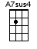

Vampire Olivia Rodrigo
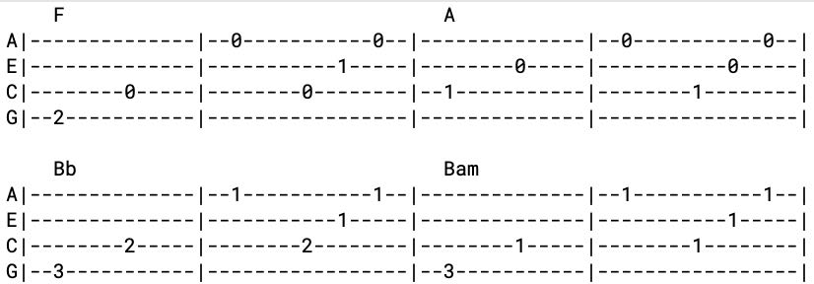
[F] [A] [Bb] [Bbm] <or intro riff>

[F↓] Hate to give the satis[F↓]faction askin' how you're doin' [A↓] now
How's the castle built off [A↓]people you pretend to care [Bb↓] about?
Just what you wanted, [Bb↓] look at [Bbm↓] you, cool guy, you got it [Bbm↓]
[F↓] I see the parties and the [F↓]diamonds sometimes when I close my
[A↓] eyes
Six months of torture you [A↓]sold as some forbidden [Bb↓] paradise
I loved you truly, [Bb↓] you gotta [Bbm↓] laugh at the stupidity [Bbm↓]

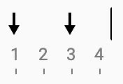
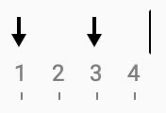
CHORUS
'Cause I've made some [Gm] real big mistakes,
But you make the [C] worst one look fine
I should've [F] known it was strange,
You only [A] come out at night
I used to [Bb] think I was smart, But you made me [Bbm] look so naïve
The way you [F] sold me for parts, As you sunk your [A] teeth into me, oh
[Bb↓] Bloodsucker, [Bbm↓] fame fucker,
[N.C.] Bleedin' me dry like a goddamn vampire

[F] <2 bars of 8th notes>

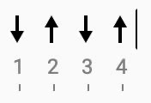
[F] And every girl I ever talked to told me you were bad, bad [A] news
You called them crazy, God, I hate the way I called 'em crazy [Bb] too
You're so convincing, how do you [Bbm] lie without flinching?
(How do you lie? How do you lie? How do you lie?)
[F] Oh, what a mesmerizin', paralyzin', fucked up little [A] thrill
Can't figure out just how you do it and God knows I never [Bb] will
Went for me and not her. ‘Cause [Bbm↓] girls your age know better

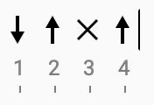
REPEAT CHORUS
[F] <2 bars 8th notes, 1 bar ½ notes, 1 bar ¼ notes>

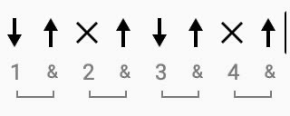
[Bb] You said it was true love
[Bbm] But wouldn't that be hard?
[F] You can't love anyone
'Cause [C] that would mean you had a heart
[Bb] I tried you help you out, [Bbm] now I know that I can't
[F] 'Cause how you think's the kind of [C] thing
I'll never understand [Bb] [Bbm] [F] [C]
REPEAT CHORUS

[F] <2 bars ½ notes, 1 bar ¼ notes, 3 bars 8th notes>

Wagon Wheel Old Crow Medicine Show
[C] Headed down south to the [G] land of the pines
I'm [Am] thumbin' my way into [F] North Caroline
[C] Starin' up the road And [G] pray to God I see [F] headlights [F]

I [C] made it down the coast in [G] seventeen hours
[Am] Pickin' me a bouquet of [F] dogwood flowers
And I'm a [C] hopin' for Raleigh I can [G] see my baby to-[F]night [F]

CHORUS
So [C] rock me mama like a [G] wagon wheel
[Am] Rock me mama any [F] way you feel
[C] Hey [G] mama [F] rock me [F]
[C] Rock me mama like the [G] wind and the rain
[Am] Rock me mama like a [F] south-bound train
[C] Hey [G] mama [F] rock me [F]

[C] Runnin' from the cold [G] up in New England
I was [Am] born to be a fiddler in an [F] old-time stringband
My [C] baby plays the guitar, [G] I pick a banjo [F] now [F]

Oh, the [C] North country winters keep a [G] gettin' me now
Lost my [Am] money playin' poker so I [F] had to up and leave
But I [C] ain't a turnin' back to [G] livin' that old life no [F] more [F]

REPEAT CHORUS

[C↓] Walkin' to the south [G↓] out of Roanoke
I caught a [Am↓] trucker out of Philly had a [F↓] nice long toke
But [C↓] he's a-headed west from the [G↓] Cumberland Gap
To [F↓] Johnson [F↓] City [F] Tennessee

And I [C] gotta get a move on [G] fit for the sun
I hear my [Am] baby callin' my name and I
[F] know that she's the only one
And [C] if I die in Raleigh At [G] least I will die [F] free [F]

REPEAT CHORUS
[C↓]

Waterloo ABBA
My, [D]my, at W[E7]aterloo
Nap[A]oleon [G]did sur[A]render
Oh [D]yeah, and [E7]I have met
my [A]desti[G]ny in [F#m]quite a [A]similar [Bm]way
The [Bm]history book on the shelf
Is [E]always repeating it[A]self [G][D][A]

[D]Waterloo - I was defeated, you [G]won the war
[A]Waterloo - Promise to love you for [D]ever more [A][A][A]
[D]Waterloo - Couldn't escape if I [G]wanted to
[A]Waterloo - Knowing my fate is to [D]be with you
Wo-wo-wo, wo-wo, [A]Waterloo - Finally facing my Wat[D]erloo

My, [D]my, I [E7]tried to hold you
[A]back but [G]you were [A]stronger
Oh [D]yeah, and [E7]now it seems
my [A]only [G]chance is [F#m]giving [A]up the [Bm]fight
And [Bm]how could I ever refuse
I [E]feel like I win when I lo[A]se [G][D][A]

[D]Waterloo - I was defeated, you [G]won the war
[A]Waterloo - Promise to love you for [D]ever more [A][A][A]
[D]Waterloo - Couldn't escape if I [G]wanted to
[A]Waterloo - Knowing my fate is to [D]be with you
Wo-wo-wo, wo-wo, [A]Waterloo - Finally facing my Wat[D]erloo

So [Bm]how could I ever refuse
I [E]feel like I win when I lo[A]se[G] [F#m][A]

[D]Waterloo - Couldn't escape if I [G]wanted to
[A]Waterloo - Knowing my fate is to [D]be with you

Wo-wo-wo, wo-wo, [A]Waterloo - Finally facing my Wat[D]erloo
[A]Waterloo - Knowing my fate is to [D]be with you
Wo-wo-wo, wo-wo, [A]Waterloo - Finally facing my Wat[D]erloo
<fade out over last 3 lines>

What’s Up? 4 Non Blondes
[A] [Bm] [D] [A] [A] [Bm] [D] [A]

[A] Twenty-five years and my life is still
[Bm] Tryin’ to get up that great big hill of [D] hope
For a desti-[A]nation
I [A] realized quickly when I knew I should
That the [Bm] world was made of this brotherhood of [D] man
For whatever that [A] means

And so I [A] cry sometimes when I'm lying in bed
Just to [Bm] get it all out what’s in my head
And I . . .[D] I am feeling a little [A] peculiar
And so I [A] wake in the morning and I step outside
And I [Bm] take a deep breath and I get real high
And I . . .[D] scream at the top of my lungs, "What’s going [A] on?”

And I say, [A] Hey –ey –ey –ey -ey, [Bm] Hey –ey -ey
I said [D] Hey, what's going [A] on?
And I say, [A] Hey –ey –ey –ey -ey, [Bm] Hey –ey -ey
I said [D] Hey, What's going [A] on?

[A] [Bm] [D] [A] [A] [Bm] [D] [A]

And I [A] try oh my God do I [Bm] try
I try all the [D] time in this insti-[A] tution
And I pray [A] oh my God do I [Bm] pray
I pray every single [D] day for a revo-[A] lution

And so I [A] cry sometimes when I'm lying in bed
Just to [Bm] get it all out what’s in my head
And I . . .[D] I am feeling a little [A] peculiar
And so I [A] wake in the morning and I step outside
And I [Bm] take a deep breath and I get real high
And I . . .[D] scream at the top of my lungs, "What’s going [A] on?”

And I say, [A] Hey –ey –ey –ey -ey, [Bm] Hey –ey -ey
I said [D] Hey, what's going [A] on?
And I say, [A] Hey –ey –ey –ey -ey, [Bm] Hey –ey -ey
I said [D] Hey, What's going [A] on?

[A] Twenty-five years and my life is still
[Bm] Trying to get up that great big hill of [D] hope
for a desti-[A↓] nation

With Or Without You U2
[D] [A] [Bm] [G] [D] [A] [Bm] [G]

[D] See the [A]stone set in your [Bm]eyes.
See the [G]thorn twist in your [D]side.
And I [A]wait…for [Bm]you. [G]

[D] Sleight of [A]hand and twist of [Bm]fate.
On a bed of [G]nails she makes me [D]wait.
And I [A]wait, with[Bm]out you. [G]

With or with[D]out you [A]...with or with[Bm]out you. [G]

[D] Through the [A]storm, we reach the [Bm]shore,
You gave it [G]all but I want [D]more.
And I'm [A]waiting [Bm]for you…[G]

With or with[D]out you [A]...with or with[Bm]out you. Ohh-[G]ohh..
I can't [D]live [A]...with or with[Bm]out you. [G]

[D] [A] [Bm] [G]

And you [D]give yourself a[A]way,
and you [Bm]give yourself a[G]way.
And you [D]give, and you [A]give,
and you [Bm]give yourself a[G]way.

[D] My hands are [A]tied, [Bm]…my body [G]bruised
She’s got me [D]with, nothing to [A]win
and [Bm]nothing left to [G]lose.
And you [D]give yourself a[A]way,
and you [Bm]give yourself a[G]way.
And you [D]give, and you [A]give,
and you [Bm]give yourself a[G]way.

With or with[D]out you [A]...with or with[Bm]out you. Ohh-[G]ohh..
I can't [D]live [A]...with or with[Bm]out you. [G]

[D]Ahh-ahh-ahh-[A]ohhh [Bm]Ahh-ahh-ahh-[G]ohhh
[D]Ahh-ahh-ahh-[A]ohhhhh[Bm]hh-ohh…[G]

With or with[D]out you [A]...with or with[Bm]out you. oh[G]ohhh
I can't [D]live [A]...with or with[Bm]out you. [G]
With or with[D]out you [A] [Bm] [G] [D↓]

Wonderful World Sam Cooke
[C] [Am] [C] Don't know much about [Am] history
[F] Don't know much bi[G7]ology
[C] Don't know much about [Am] science book
[F] Don't know much about the [G7] French I took

[C] But I do know that [F] I love you
[C] And I know that if you [F] love me too
What a [G] wonderful [F] world this would [C] be [Am]

[C] Don't know much about ge[Am]ography
[F] Don't know much trigo[G7]nometry
[C] Don't know much about [Am] algebra
[F] Don't know what a slide [G7] rule is for

[C] But I do know one and [F] one is two
[C] And if this one could [F] be with you
What a [G7] wonderful [F] world this would [C] be [Am]

Now [G7] I don't claim to [C] be an A student
[G7] but I'm trying to [C] be
For [D7] maybe by being an [C] A student baby
[D7] I can win your [G7] love for me

[C] Don't know much about [Am] history
[F] don't know much bi[G7]ology
[C] Don't know much about [Am] science book
[F] Don't know much about the [G7] French I took

[C] But I do know that [F] I love you
[C] And I know that if you [F] love me too
What a [G] wonderful [F] world this would [C] be

[C] La ta ta ta ta ta ta [Am] history
[F] Ooh ooh ooh ooh ooh oohh bi[G7]ology
[C] La ta ta ta ta ta ta [Am] science book
[F] Ooh ooh ooh ooh ooh ooh [G7] French I took

[C] But I do know that [F] I love you
[C] And I know that if you [F] love me too
What a [G7] wonderful [F] world this would [C] be [G7↓] [C↓]

